

SuiteTooth:
BluetoothTM Simulation
Model Suite
for
OPNETTM

Highland Systems, Inc.
679 E. 2nd Ave, Suite E2
Durango, CO 81301

Table of Contents
1 Introduction 7
1.1 Overview 7
1.2 Background Requirements 7
1.3 Document Organization 7
1.4 Modeling Paradigm – The OPNET™ Environment 8
2 Model Implementation 9
2.1 Overview 9
2.2 Bluetooth™ Model 10
2.2.1 Origin 10
2.2.2 Features 11
2.2.3 Limitations 12
2.3 WLAN Model 12
2.3.1 Model Origin 12
2.3.2 Features 12
2.3.3 Limitations 13
2.4 Independent Stochastic Traffic Sources 13
2.5 Client/Server Traffic Sources 13
2.6 Interference Sources 14
3 SuiteTooth Installation 15
3.1 System Requirements 15
3.2 Model Installation 15
3.3 Verifying installation 15
4 SuiteTooth Utilities 16
4.1 Scenario Creation Utility 16
4.1.1 Scenario Creation Utility Overview 16
4.1.2 Operation of Scenario Creation Utility 17
4.1.3 Scenario Creation Utility Installation Verification 19
4.2 Modulation Curve Creation Utility 21
4.2.1 Modulation Curve Creation Utility Overview 21
4.2.2 Creating a Modulation Curve 21
5 SuiteTooth Model Reference 22
5.1 Network Model Reference 22
5.1.1 Top Layer Network 23
5.1.2 Bluetooth™ Network Subnetwork 23
5.2 Node Model Reference 25
5.2.1 bt_master_nd.nd.m 25
5.2.2 bt_slave_nd.nd.m 29
5.2.3 Common WLAN Parameters 31
5.2.4 coexist_wlan_eth_bridge_adv.nd.m 33
5.2.5 coexist_wlan_ethernet_router_adv.nd.m 35
5.2.6 coexist_wlan_server_adv.nd.m 38
5.2.7 coexist_wlan_station_adv.nd.m 40
5.2.8 coexist_wlan_wkstn_adv.nd.m 42
5.2.9 suitetooth_app_model.nd.m and suitetooth_profile_model.nd.m 44
5.2.10 jammer.nd.m 46
5.3 Process Model Reference 48
5.3.1 bt_master.pr.m 48
5.3.2 bt_master_arp.pr.m 50
5.3.3 bt_mst_lmp_src_sink.pr.m 51
5.3.4 bt_mst_sto_src_sink.pr.m 52
5.3.5 bt_slave.pr.m 53
5.3.6 bt_slave_arp.pr.m 54
5.3.7 bt_slave_lmp_src_sink.pr.m 55
5.3.8 bt_slave_sto_src_sink.pr.m 56
5.3.9 Bluetooth™ transmitter and receiver 57
5.3.10 WLAN transmitter and receiver 58
5.3.11 jammer_source.pr.m 59
5.4 Packet Model Reference 59
5.4.1 Bluetooth™ Packet Types 59
5.4.2 WLAN Packet Types 64
5.5 Radio Pipeline Reference 66
5.5.1 Overview 66
5.5.2 Receiver Group 68
5.5.3 Transmission Delay 69
5.5.4 Link Closure 69
5.5.5 Channel Match 70
5.5.6 Transmitter Antenna Gain 71
5.5.7 Propagation Delay 71
5.5.8 Receiver Antenna Gain 72
5.5.9 Received Power 72
5.5.10 Background Noise 73
5.5.11 Interference Noise 74
5.5.12 Signal to Noise Ratio (SNR) 74
5.5.13 Bit Error Rate (BER) 75
5.5.14 Error Allocation 76
5.5.15 Error Correction 77
5.6 Statistics Reference 78
6 Appendix A – Bluetooth™ Protocol Features 82
7 Appendix B – Included Files 85
8 Appendix C – REFERENCES 87

LIST OF FIGURES

Figure 1 – The Three-Tiered OPNET™ Hierarchy 8
Figure 2 – Example SuiteTooth Network Model 9
Figure 3 – Example Full Protocol Stack Model 10
Figure 4 – New project with empty scenario 16
Figure 5 – SuiteTooth Scenario Creation Utility Window 17
Figure 6 – SuiteToothtest scenario 19
Figure 7 – Choose results 20
Figure 8 – Results from example scenario 20
Figure 9 – Top Layer Network 23
Figure 10 – Bluetooth™ Network Subnetwork 24
Figure 11 – Bluetooth™ Master Node Model 25
Figure 12 – Bluetooth™ Slave Node Model 29
Figure 13 – WLAN Ethernet Bridge Node Model 33
Figure 14 – WLAN Ethernet Router Node Model 35
Figure 15 – WLAN Server Node Model 38
Figure 16 – WLAN Station Node Model 40
Figure 17 – WLAN Workstation Node Model 42
Figure 18 – SuiteTooth Configuration Node Models 44
Figure 19 – Jammer Node Model 46
Figure 20 – Bluetooth™ Master Process Model 49
Figure 21 – Bluetooth™ Master ARP Process Model 50
Figure 22 – Bluetooth™ Master Link Manager Protocol (LMP) Process Model 51
Figure 23 – Bluetooth™ Master Stochastic Source/Sink Process Model 52
Figure 24 – Bluetooth™ Slave Process Model 53
Figure 25 – Bluetooth™ Slave ARP Process Model 54
Figure 26 – Bluetooth™ Slave Link Manager Protocol (LMP) Process Model 55
Figure 27 – Bluetooth™ Slave Stochastic Source/Sink Process Model 56
Figure 28 – Jammer Source Process Model 59
Figure 29 – DH1 Packet 63
Figure 30 – HV1 Packet 63
Figure 31 – POLL Packet 64
Figure 32 – wlan_mac Packet 65
Figure 33 – wlan_control Packet 65

LIST OF TABLES

Table 1 – Scenario Creation Utility Options 18
Table 2 – Network Level Model Objects 22
Table 3 - Network Object Attributes 24
Table 4 – Bluetooth™ Master Node Process Models 26
Table 5 – Bluetooth™ Master Node Attributes 27
Table 6 – Bluetooth™ Slave Node Process Models 30
Table 7 – Bluetooth™ Slave Node Attributes 31
Table 8 – SuiteTooth WLAN Parameters 32
Table 9 – WLAN Ethernet Bridge Node Process Models 34
Table 10 – WLAN Ethernet Bridge Node Attributes 34
Table 11 – WLAN Ethernet Router Node Process Models 36
Table 12 – WLAN Ethernet Router Node Attributes 37
Table 13 – WLAN Server Node Process Models 39
Table 14 – WLAN Server Node Attributes 39
Table 15 – WLAN Station Node Process Models 41
Table 16 – WLAN Station Node Attributes 41
Table 17 – WLAN Workstation Node Process Models 43
Table 18 – WLAN Workstation Node Attributes 43
Table 19 – Application and Profile Node Process Models 45
Table 20 – Application and Profile Node Attributes 45
Table 21 – Jammer Node Process Models 46
Table 22 – Jammer Node Attributes 47
Table 23 – Bluetooth™ Transmitter Attributes 57
Table 24 – Bluetooth™ Receiver Attributes 57
Table 25 – Coexistence WLAN Transmitter Attributes 58
Table 26 – Coexistence WLAN Receiver Attributes 58
Table 27 – SuiteTooth Packet Field Data Types and Sizes 61
Table 28 – Packet Fields by Packet 62
Table 29 – Bluetooth Pipeline Stages Overview 66
Table 30 – WLAN Pipeline Stages Overview 67
Table 31 – Bluetooth™ Protocol Requirements List 82
Table 32 – List of Files in the SuiteTooth_models Directory 85
Table 33 – List of files in the SuiteTooth_ets Directory 86

Introduction

Overview
Highland Systems’ Bluetooth™ Simulation Model Suite (SuiteTooth) is an open, modular framework for advanced network performance engineering. Built for the OPNET™ simulation environment, the high fidelity, discrete-event SuiteTooth models allow users to predict performance characteristics and study behavioral interaction for personal area network (PAN) applications that use both existing and emerging wireless technologies.

Background Requirements
It is assumed that the reader of this document is familiar with the Bluetooth™ and WLAN protocols and relevant networking terminology. It is also assumed that the user of the SuiteTooth Models is familiar with OPNET™ concepts, OPNET™ terminology, and is able to navigate the OPNET™ toolset. This knowledge is typically acquired by completing OPNET™ Tutorials and an OPNET™ basic training course, in addition to using OPNET™ to build models.

Document Organization
The main sections of this document are briefly described here.

- Section 2, Model Implementation, describes the SuiteTooth models from a functional standpoint. The origin, features, assumptions and limitations of the various protocol implementations are discussed.

- Section 3, SuiteTooth Installation, describes the installation and model activation procedure.

- Section 4, SuiteTooth Utilities, describes two utilities:

  - A scenario creation utility that assists the user in creating operating scenarios with both Bluetooth™ and WLAN nodes.
  - A modulation curve creation utility that builds an OPNET™ modulation curve from user supplied known BER vs. Eb/No pairs.

- Section 5, SuiteTooth Model Reference, is the SuiteTooth Model reference. All network, node, and process models are described in detail. This section will be most useful to the model user developing custom scenarios.

Modeling Paradigm – The OPNET™ Environment
OPNET™ provides a comprehensive development environment supporting the modeling of communication networks and distributed systems. Both behavior and performance of modeled systems can be analyzed by performing discrete event simulations. The OPNET™ environment incorporates tools for all phases of a study, including model design, simulation, data collection, and data analysis.

OPNET™ Models are structured hierarchically, in a manner that parallels real network systems. Specialized editors address issues at different levels of the hierarchy. This provides an intuitive modeling environment and permits re-use of lower level models.

Figure 1 – The Three-Tiered OPNET™ Hierarchy
A network model may contain any number of communicating entities called nodes. Nodes are instances of node models, developed using the Node Editor. Modelers can develop their own library of customized node models, implementing any functionality they require.

Network models consist of nodes and links that can be deployed within a geographical context. OPNET™ provides fixed nodes and point-to-point and bus links; the Radio version in addition provides mobile and satellite nodes, and radio links.

Model Implementation
This section describes the SuiteTooth models from a functional standpoint. The origin, features, assumptions and limitations of the various protocol implementations are discussed.

Overview
The SuiteTooth models support comprehensive analysis that accounts for all pertinent data flow and interference within a local area:

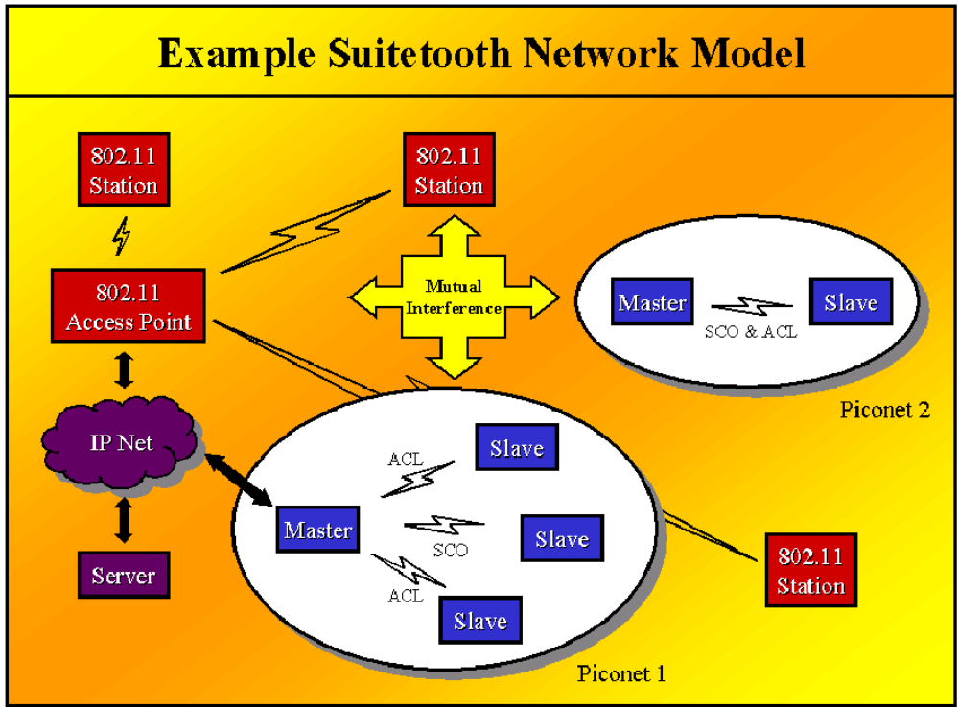
Figure 2 – Example SuiteTooth Network Model
The model suite supports studies of:
- Application Performance
- Protocol Stack Integration
- Link Layer Framing & Scheduling
- Radio Performance
- Channel Access and Utilization
- RF Interference Effects
- Adaptive Feedback Mechanisms

Target analysis scenarios range from a single Master/Slave session to multiple co-located piconets with multiple interference sources. All model components are provided in source format so that they may be inspected, modified, and extended by the model user.

The SuiteTooth models capture appropriate behavioral logic at all pertinent layers and interfaces. The models may be driven by simple stochastic traffic sources, or by interactive client/server application models that include a full protocol stack:

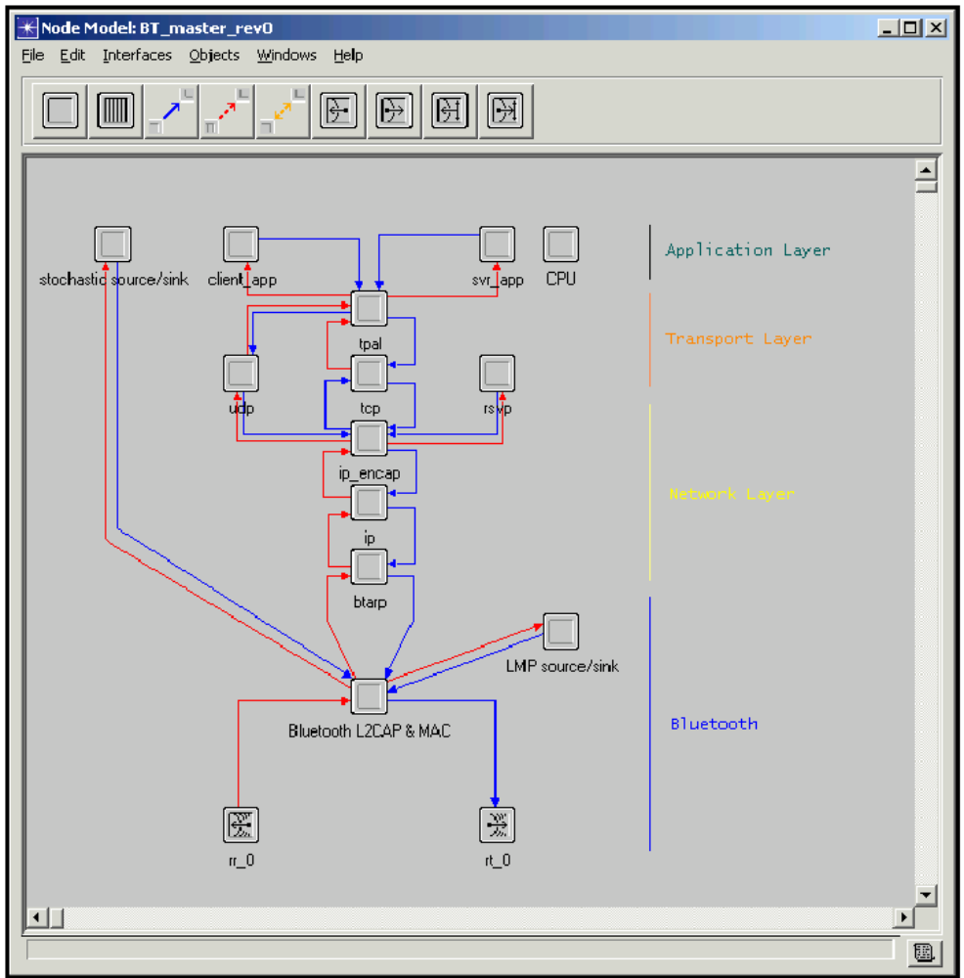
Figure 3 – Example Full Protocol Stack Model

Bluetooth™ Model

Origin
HSI first designed and implemented a Bluetooth™ protocol simulation model as a consultant. The expertise gained in this work, along with the growing popularity of the protocol, prompted HSI to create a commercially available model.

Features
Data Link Layer

Key functionality has been extracted from the Bluetooth™ specifications to capture important systems performance characteristics for active data flows:

- Services
  - Asynchronous Connectionless (ACL)
  - Synchronous Connection-Oriented (SCO)
  - Multiple piconets
  - Up to 7 slaves per piconet
- Framing
  - High and Medium Speed Services
  - 1, 3, and 5 Slot Packets
  - ACL Frames: D <H|M> <1|3|5>
  - SCO Frames: HV <1|2|3>
- Scheduler
  - Modular scheduling algorithm selects fixed, variable, or user-defined frame sizes
  - Independent scheduling logic at Master and Slave nodes
  - Polling behavior, including NULL response frames
  - Higher precedence given to LMP traffic
- L2CAP
  - Application multiplexing
  - Segmentation and Reassembly (SAR) services
- LMP
  - Built-in traffic sources for stochastic modeling of control traffic volume
  - Process may be extended to include explicit user-defined LMP signaling
- Baseband
  - Transmission and Reception Timing for PHY Frames
  - FEC performance on SCO frames (1/3, 2/3, none)
  - 2/3 FEC performance on ACL medium rate frames (DM<1|3|5>)

Physical Layer

The core of the physical channel model is an explicit representation of the RF spectrum. Timing, frequency, bandwidth, modulation, and radiated power are explicitly modeled for all transmissions. The impact of radio performance and dynamic interference in the RF channel account for data corruption and loss that impact higher layer processes.

ISM Band Coexistence

SuiteTooth includes an adaptation of the OPNET™ standard 802.11b wireless LAN model that is interoperable with the Bluetooth™ physical layer. These models allow the effects of ISM band coexistence between the two systems to be quantified within the context of free space, indoor, and user-defined path loss models. The RF channel models are provided in source format and may be adapted to other ISM band technologies.

Limitations
The Protocol Requirement List in Appendix A contains a comprehensive list of features supported by the model, as well as protocol features that are beyond the scope of SuiteTooth. The model limitations are listed below.

Scatternets are not modeled in this release.

The model supports a single SCO connection per slave. Slaves can additionally support an ACL link. Up to three SCO connections are supported within a piconet, provided there is a unique slave for each SCO connection.

Scheduler: if any SCO connections are present within a piconet, the slaves can only transmit single slot ACL packets. The master can transmit ACL on three slots if the SCO connection utilizes HV3 packet types and there is not more than one SCO connection.

States: only the connection – active state is modeled.

Radio performance: the BER for a packet segment is determined by a lookup in the “modulation curve”, an OPNET™ construct of Eb/No vs. BER values. The return BER value is a function of Eb/No (SNR + processing gain) for the segment. The modulation curve is specific to a radio’s known BER vs. Eb/No values. The default SuiteTooth modulation curve, Bluehoc, was generated using data from the IBM Bluehoc radio performance evaluation, http://www-124.ibm.com/developerworks/opensource/bluehoc/pres/pres2/index.htm. Bluetooth™ interference measurements for a given system are dependent on accurate modulation curve data for the radios of interest.

WLAN Model

Model Origin
A realistic modeling of Bluetooth™ transmissions will naturally have to take into account other types of wireless transmissions taking place in the same space. SuiteTooth WLAN models provide physical layer modeling that will allow different types of wireless transmissions to interfere with each other, making coexistence studies possible.

Features
The standard OPNET™ 802.11b wireless LAN model provides the user with a means to study wireless LAN behavior at the MAC level and above. The features of the higher layers of the WLAN models in SuiteTooth are the same as those in the standard OPNET™ WLAN models.

For detailed information on the features of the WLAN model, OPNET™ offers a model usage guide entitled “Wireless LAN Model Description”, which can be found online.

Physical Layer

The core of the physical channel model is an explicit representation of the RF spectrum. Timing, frequency, bandwidth, modulation, and radiated power are explicitly modeled for all transmissions. The impact of radio performance and dynamic interference in the RF channel account for data corruption and loss that impact higher layer processes.

ISM Band Coexistence

SuiteTooth includes an adaptation of the OPNET™ standard 802.11b wireless LAN model that is interoperable with the Bluetooth™ physical layer. These models allow the effects of ISM band coexistence between the two systems to be quantified within the context of free space, indoor, and user-defined path loss models. The RF channel models are provided in source format and may be adapted to other ISM band technologies.

Limitations
The SuiteTooth WLAN models have some of the limitations of the standard WLAN models:
- All stations can be designated as access points, but only WLAN routers can connect a BSS to the distribution system.
- WLAN packets from a different subnet will be received as noise.

Radio performance modeling depends on having a modulation curve that is specific to a radio’s known BER vs. Eb/No values. Interference measurements for a given system are dependent on accurate modulation curve data for the radios of interest.

Independent Stochastic Traffic Sources
The independent, renewal-process based traffic sources create a tightly controlled experimental environment for exercising the Data Link Layer and Physical Layer models. System behavior above Bluetooth™ is abstracted into simple stochastic traffic sources and sinks. Traffic flows between Bluetooth™ nodes are specified using packet interarrival time and packet size probability distribution functions (PDFs) for each user-defined flow.

Client/Server Traffic Sources
The client/server protocol stack is based on the OPNET™ Standard Model Library. It provides sophisticated, interactive application traffic models:
- Application Layer
  - Application Mix Profile web browsing (HTTP 1.0 and 1.1), file transfer, e-mail upload/download, voice and video over IP, custom applications
  - Application Instance Activation (interarrival PDF)
  - Application Transaction Characteristics (interarrival and size PDFs)
- Transport Layer
  - TCP
  - UDP
- Network Layer
  - IP with QOS support

Interference Sources
The jammer model represents a generic jammer that can be deployed as fixed or mobile. It provides transmissions over the user specified frequency, bandwidth and power at any rate. The user can specify the following:
- Packet Interarrival Time
- Packet Size
- Bandwidth
- Minimum Frequency
- Transmission Power

This generic jammer allows the user to represent any source by setting the above attributes.

The SuiteTooth jammer model uses the same physical layer modeling as the Bluetooth™ and WLAN nodes and can be used in coexistence scenarios to simulate other types of interference.

SuiteTooth Installation

System Requirements
The version of the SuiteTooth model suite provided with this document will run with version 9.1.A of OPNET™ Modeler on a Windows operating system. This model suite was developed using Windows 2000 Professional and it is expected to work with any Windows operating system supported by OPNET.

As with any comprehensive computer model, performance is very dependent on processor speed and available RAM. RAM requirements vary with the size of the network being modeled. Minimum recommendations are 500 MHz PII processor and 256 MB RAM for Windows systems. This may be insufficient for networks in excess of 100 nodes.

Model Installation
The SuiteTooth model suite should unzip to three directories. The SuiteTooth_models folder holds the node, packet, and process models used for SuiteTooth, as well as other files used to create scenarios or view results. The SuiteTooth_scenarios folder has some sample scenarios. The SuiteTooth_ets folder contains the SuiteTooth Scenario Creation Utility files necessary for automatic scenario generation.

To install the SuiteTooth models, simply copy these directories to your op_models directory (or another preferred local workspace). The path to these directories must be included in the model directory (mod_dirs) of the current OPNET™ environment file (env_db). It is recommended that the Scenarios directory be first in the list.

The path to the ETS directory must also be included in the system “PATH” for the Scenario Creation Utility to operate correctly. To edit the system path:
- Right click on the “My Computer” icon and select Properties.
- In the “System Properties” window, choose the “Advanced” tab.
- In the “Advanced” window click on the “Environment Variables…” button.
- Edit the “path” variable in the User variables (top) window.
- At the end of the Variable Value list (which may be quite long), add a semi-colon and then your path to the ETS directory.

Appendix B briefly describes the included SuiteTooth files.

Verifying installation
To verify that you can use the model, it is suggested that you duplicate one of the enclosed scenarios and "run" with the default parameter settings.

SuiteTooth Utilities

Scenario Creation Utility

Scenario Creation Utility Overview
The Scenario Creation Utility may not be available for certain versions of OPNET™.
This section describes how to create a very simple Bluetooth™ network by using the SuiteTooth Scenario Creation Utility. Basic Scenario Creation Utility functionality is also covered. Try creating a new OPNET™ project with an empty scenario. The example project shown in figure 3 is called bluetooth_install_check. Verify that the SuiteTooth buttons appear on the toolbar. Note the large “radio laptop” icon on the “Create new SuiteTooth model” button at the left of the toolbar in figure 4.

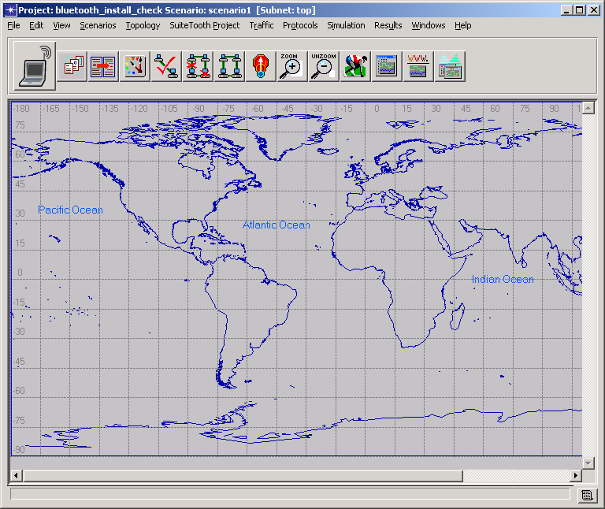
Figure 4 – New project with empty scenario

Operation of Scenario Creation Utility
Click the “Create new SuiteTooth model” button to bring up the following dialog box:

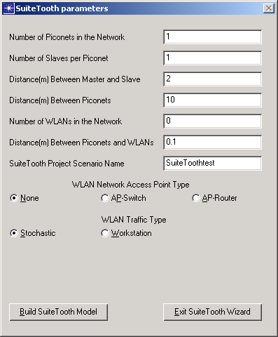
Figure 5 – SuiteTooth Scenario Creation Utility Window

Table 1 describes the meaning of the various fields and radio button groups in the Scenario Creation Utility.
Table 1 – Scenario Creation Utility Options
Attribute name | Description | Type/Default
Number of Piconets in the Network | Number of Piconets (master/slave) to be created. | Integer  (1)
Number of Slaves Per Piconet | Number of slave objects to be created with each piconet. | Integer  (1)
Distance(m) Between Master and Slave | Slave objects are created and placed in a circle around the master. This attribute defines the radius of the circle in meters. | Float  (2)
Distance(m) Between Piconets | Distance in meters between the centers of the master objects of a piconet. The piconets will be placed on a dynamically sized grid with this distance separating them from any other piconet. | Float  (10)
Number of WLANs in the Network | Number of WLAN objects (workstations or stochastic generators) to be created. | Integer  (0)
Distance Between Piconets and WLANs | WLAN objects will have the same x coordinates in the grid as their matching piconet objects, but will be separated vertically from the piconets by this distance in meters. Large values here can be used to separate entire WLAN networks from piconet networks. | Float  (0.1)
SuiteTooth Project Scenario Name | The name of the new scenario the creation utility will create. | String  (SuiteToothtest)
WLAN Network Access Point Type radio button group | This radio button group defines which type of access point will be used by the WLAN objects to access external servers. Choices are no access point (normal server), a switch, or a router. | Unique  (None)
WLAN Traffic Type radio button group | This radio button group defines which type of WLAN objects to create. Choices are workstations (full protocol stack) or stochastic traffic generators. | Unique  (Stochastic)

Scenario Creation Utility Installation Verification
In this example, all default parameters are used. Click on the “Build SuiteTooth Model” button at the lower left of the dialog box to create a new scenario with the name “SuiteToothtest.”

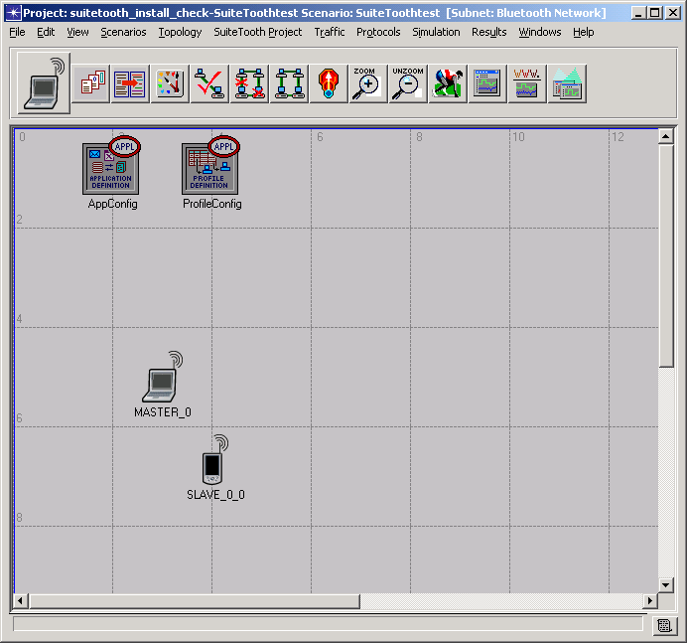
Figure 6 – SuiteToothtest scenario
Edit the attributes on SLAVE_0 to set the following parameters:
- Slave Address – check to be sure it is set to Slave 0
- Bluetooth™ Radio Modulation – should be set to Bluehoc
- Application: Supported Profiles – set a single profile to “Engineer.”
Be sure the Bluetooth™ Radio Modulation is set to Bluehoc on MASTER_0.

Right click in the scenario background to Choose Individual Statistics and select the following results:

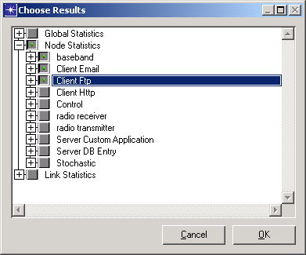
Figure 7 – Choose results
Run the scenario for 3 minutes. This should take approximately 1 minute on a Windows 2000 Professional computer with a 1GHz PIII processor. Examine and verify the following results:

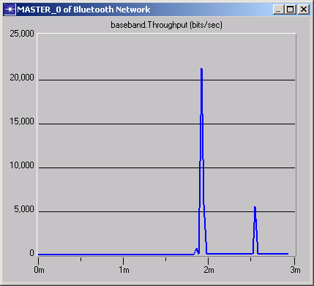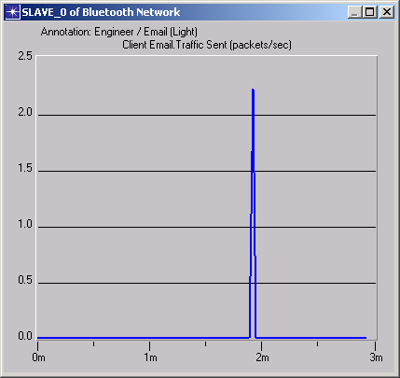
Figure 8 – Results from example scenario

Modulation Curve Creation Utility

Modulation Curve Creation Utility Overview
Radio performance in SuiteTooth is tightly coupled with the modulation curve used in the Bluetooth™ and WLAN models. In brief, the modulation curve provides a lookup of bit error rates for Eb/No values. OPNET™ does provide an interface to construct a modulation curve, but it is much easier and accurate to construct the curve using this utility.

By default, SuiteTooth uses the “Bluehoc” modulation curve for Bluetooth™ . The points on this curve are derived from Eb/No vs. BER data available on the IBM/Bluehoc site. The default for WLAN is CCK_11mbps. It was derived from experimental data points for an actual WLAN system. We recommend using known value pairs, if available, to construct custom modulation curves, as this will have large effects on radio performance, especially coexistence and mutual interference issues.

The Modulation Curve Creation Utility takes a set of known values of BER at specific Eb/No levels and generates a modulation curve that can be used by OPNET™ models. The utility will use logarithmic linear interpolation to create intermediate points on the curve, simplifying the process of developing a customized modulation curve.

The Modulation Curve Creation Utility can use as input up to 100 value pairs without modification. The source code for the utility is included to allow for adjustments such as increasing the number of value pairs. Changes to the utility may be made in the ber_calc_log.em.c file, using “op_mkema -type ps -m ber_calc_log” to rebuild the executable from the command line.

Creating a Modulation Curve
Prepare a text input file with known BER to Eb/No value pairs. An example file called ber.txt is included in the model directory. This file must be saved to the same directory as the executable (ber_calc_log.i0.em.x).

Run the executable from an OPNET™ console using the full name with extensions. You will be prompted for the name of your input file and the name that will be used for the new modulation curve. Next, you will be asked for the number of points desired between the minimum and maximum Eb/No values. New points will be generated by interpolating between the given points on the curve.

The new modulation curve will be created in the directory at the top of your mod_dirs list. View it by refreshing model directories, click File -> Open -> Modulation Curve
-> choose your new curve (a Wireless license may be required to view your modulation curve).

SuiteTooth Model Reference

Network Model Reference

Table 2 – Network Level Model Objects
Construct | OPNET™ Object Class | Quantity per Scenario | Function
Top Layer | Network | 1 | - Contains Bluetooth™ Subnetwork.
Bluetooth™Subnetwork | Sub-network | 1 | - Placeholder for SuiteTooth network components
App Config | Node | 1 | - Defines specific applications for traffic generation in the model.
Profile Config | Node | 1 | - Defines the distribution and sequencing of specific applications that are used by the client nodes to generate traffic in the model.
Bluetooth™Master node | Node | 1-100 | - Represents a device using the Bluetooth™ protocol in the master mode.
Bluetooth™Slave Node | Node | 1-7 per piconet | - Represents a device using the Bluetooth™ protocol in the slave mode.
WLAN Workstation Node | Node | 0-100 | - Represents a WLAN workstation that can run applications over TCP/IP or UDP.
WLAN Station Node | Node | 0-100 | - Represents a simple WLAN station with a stochastic source and a sink.

Top Layer Network
The figure below depicts a sample network model at the top subnet level. This layer is simply a placeholder for the Bluetooth™ Network subnetwork

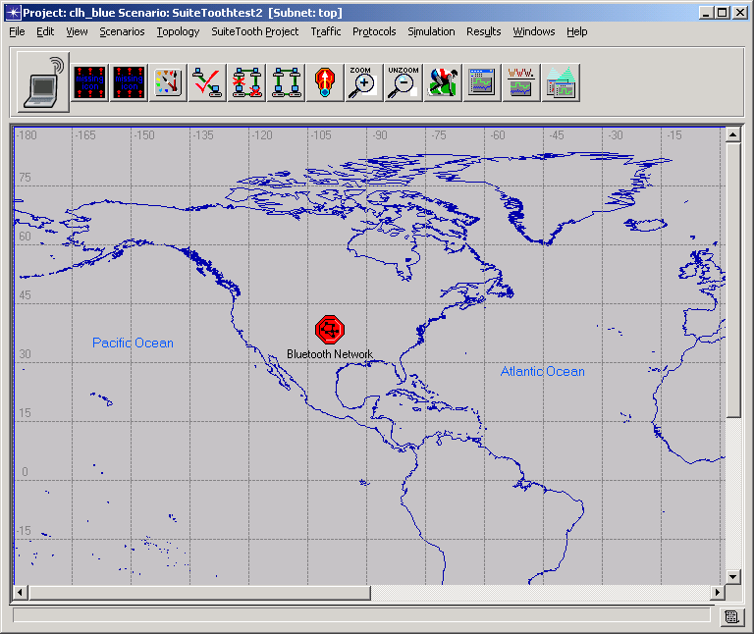
Figure 9 – Top Layer Network

Bluetooth™ Network Subnetwork
The Bluetooth™ Network subnetwork object is the repository for all network node objects created by the SuiteTooth Scenario Creation Utility.

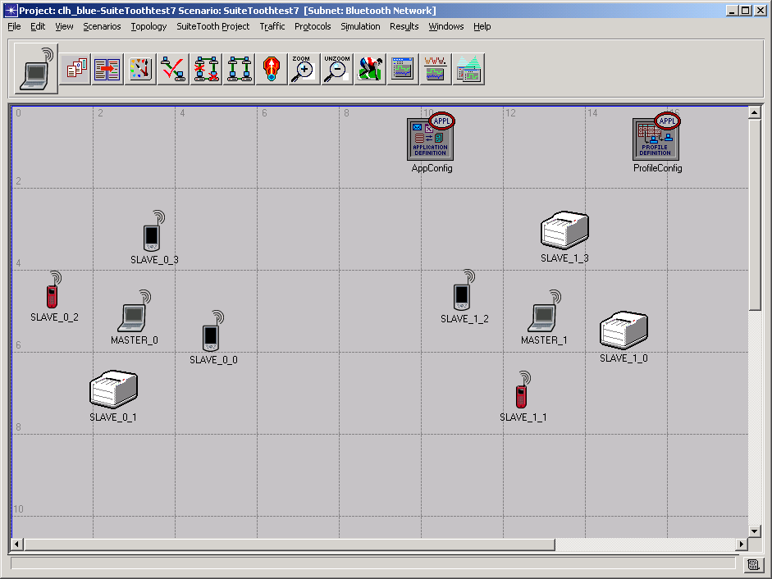
Figure 10 – Bluetooth™ Network Subnetwork

Table 3 - Network Object Attributes
Attribute name | Description | Type  (Default)
Client Application: Segment Size (bits) | The maximum size of any segment that will be passed on to the TPAL layer from the application. Measured in bytes. | Integer  (64,000)

Node Model Reference

bt_master_nd.nd.m

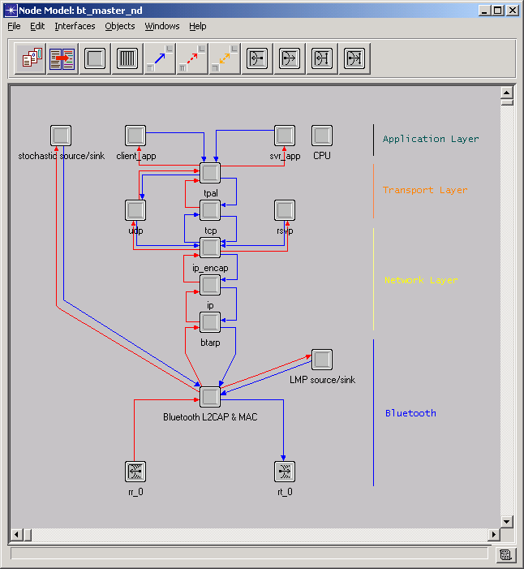
Figure 11 – Bluetooth™ Master Node Model

Table 4 – Bluetooth™ Master Node Process Models
Object Name | Model | Class | Description
stochastic source/sink | bt_mst_sto_src_sink | Processor | - Stochastic renewal traffic source for ACL and SCO
client_app | gna_clsvr_mgr | Processor | - Standard OPNET™ client-server process
svr_app | gna_clsvr_mgr | Processor | - Standard OPNET™ client-server process
CPU | server_mgr | Processor | - Standard OPNET™ server manager process
tpal | tpal_v3 | Processor | - Standard OPNET™ TPAL process
tcp | tcp_manager_v3 | Processor | - Standard OPNET™ TCP process
udp | rip_udp_v3 | Processor | - Standard OPNET™ UDP process
rsvp | rsvp | Processor | - Standard OPNET™ RSVP process
ip_encap | ip_encap_v4 | Processor | - Standard OPNET™ IP encapsulation process
ip | ip_dispatch | Processor | - Standard OPNET™ IP process
btarp | bt_master_arp | Processor | - Analogous to ARP, maps slave am_addrs to IP addresses
LMP source/sink | bt_mst_lmp_src_sink | Processor | - Stochastic renewal traffic source for LMP Control messages
Bluetooth™ L2CAP & MAC | bt_master | Processor | - Bluetooth™ master MAC logic
rr_0 | receiver object | Radio Transceiver | - Bluetooth™ radio receiver
rt_0 | transmitter object | Radio Transceiver | - Bluetooth™ radio transmitter

Table 5 – Bluetooth™ Master Node Attributes
Attribute name | Description | Type  (Default)
ACL Slot Length | - Determines how many 625μs timeslots the master will use for ACL transmissions. | list choice  (1 slot)
Bluetooth™ Radio Modulation | - Determines the Modulation Curve used for Eb/No vs. BER lookups used in the Bluetooth™ radio pipeline stages. This attribute must be the same for all nodes within a piconet for successful reception. | filename  (Bluehoc)
Bluetooth™ Transmit Power (W) | - Bluetooth™ radio transmitter power in Watts. | float (0.001)
Initial ACL Data Rate | - Sets ACL to transmit without FEC (high data rate, DH<1|3|5>) or with 2/3 FEC (medium data rate, DM<1|3|5>). | list choice  (High Data Rate (no FEC))
Master->Slave ACL Traffic | - Allows configuration of the stochastic renewal traffic for ACL links. | List choice  (No Data)
Master->Slave Control Traffic | - Allows configuration of the stochastic renewal traffic for LMP/Control messages. | List choice  (No Control)
Master->Slave SCO Traffic | - Allows configuration of the stochastic renewal traffic for SCO links. | List choice  (No Voice)
Piconet Address | - Integer value identifying a piconet. Within a network model, piconet addresses must begin at zero and increment by one. | Integer (unique)
Piconet Timing Offset | - A value of 0 to .00125 seconds (2 timeslots) by which differing piconets within a network have TDD timing offsets. | Double  (Random)
Polling Interval | - The maximum number of timeslots for which slaves within a piconet are guaranteed to receive a transmission. | Integer (40)
SCO Packet Type | - Determines the level of FEC and consequently Tsco (number of timeslots between successive SCO transmissions for a single SCO connection) used for all SCO connections in the piconet.  - HV3  - Tsco = 6  - no FEC  - max 3/piconet  - HV2  - Tsco = 4  - 2/3 FEC  - max 2/piconet  - HV1  - Tsco = 2  - 1/3 FEC  - max 1/piconet | list choice  (HV3)
Server Address | - Unique name that identifies this node as a server for OPNET™ standard applications. | string (unique)
Slave ACL Slot Length | - Sets the length of packets used by the slaves of this piconet. This setting can be overridden by the slaves on a per-node basis by setting the slave’s “ACL Slot Length”. | list choice  (1 slot)
Voice Start Time | - Time that SCO stochastic traffic sources begin to generate packets. | float (1.0)

bt_slave_nd.nd.m

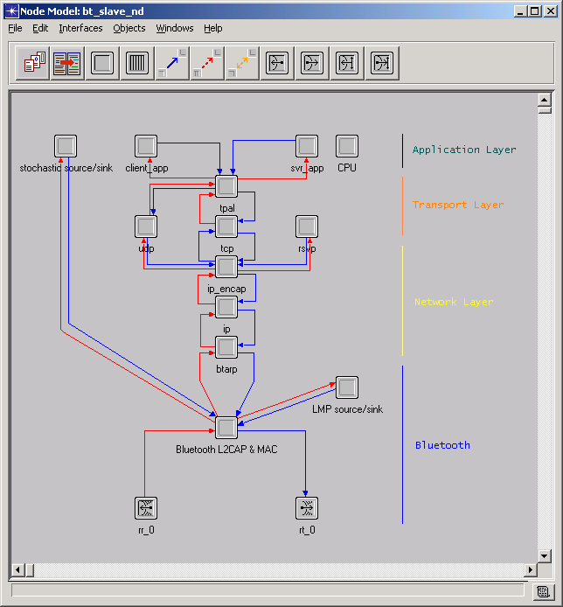
Figure 12 – Bluetooth™ Slave Node Model

Table 6 – Bluetooth™ Slave Node Process Models
Object Name | Model | Class | Description
stochastic source/sink | bt_slave_sto_src_sink | Processor | - Stochastic renewal traffic source for ACL and SCO
client_app | gna_clsvr_mgr | Processor | - Standard OPNET™ client-server process
svr_app | gna_clsvr_mgr | Processor | - Standard OPNET™ client-server process
CPU | server_mgr | Processor | - Standard OPNET™ server manager process
tpal | tpal_v3 | Processor | - Standard OPNET™ TPAL process
tcp | tcp_manager_v3 | Processor | - Standard OPNET™ TCP process
udp | rip_udp_v3 | Processor | - Standard OPNET™ UDP process
rsvp | rsvp | Processor | - Standard OPNET™ RSVP process
ip_encap | ip_encap_v4 | Processor | - Standard OPNET™ IP encapsulation process
ip | ip_dispatch | Processor | - Standard OPNET™ IP process
btarp | bt_slave_arp | Processor | - Analogous to ARP, maps slave am_addrs to IP addresses
LMP source/sink | bt_slave_lmp_src_sink | Processor | - Stochastic renewal traffic source for LMP Control messages
Bluetooth™ L2CAP & MAC | bt_slave | Processor | - Bluetooth™ slave MAC logic
rr_0 | receiver object | Radio Transceiver | - Bluetooth™ radio receiver
rt_0 | transmitter object | Radio Transceiver | - Bluetooth™ radio transmitter

Table 7 – Bluetooth™ Slave Node Attributes
Attribute name | Description | Type  (Default)
ACL Slot Length | - Used to override settings from the master. This setting takes precedence over the master’s setting for slaves. | list choice  (master will assign)
Bluetooth™ Radio Modulation | - Determines the Modulation Curve used for Eb/No vs. BER lookups used in the Bluetooth™ radio pipeline stages. This attribute must be the same for all nodes within a piconet for successful reception. | filename  (Bluehoc)
Bluetooth™ Transmit Power (W) | - Bluetooth™ radio transmitter power in Watts. | float (0.001)
Piconet Address | - Matches this slave to its master | Integer (unique)
Server Address | - Identifies this node as a server for OPNET™ standard applications. | string (unique)
Slave Address | - Maps to a value of 0-6. Must start at zero and increase stepwise. | list choice  (master will assign)
Slave Control Parameters | - Allows configuration of the stochastic renewal traffic for LMP/Control messages. | No Control
Slave Traffic Parameters | - Allows configuration of the stochastic renewal traffic for ACL and SCO links. | None
Voice Start Time | - Start time for voice stochastic traffic sources. | float (1.0)

Common WLAN Parameters
The SuiteTooth WLAN models that follow have all been given a set of WLAN parameters that is different from the default parameters of the standard OPNET™ WLAN models. The parameter settings used for default SuiteTooth transmissions are shown in the table below.

Table 8 – SuiteTooth WLAN Parameters
Attribute name | Description | Default
Rts Threshold | - Data from the higher layer greater than this size must use RTS | None
Fragmentation Threshold | - Data from the higher layer greater than this size must be fragmented | None
Data Rate | - Choice of the four data rates supported by the model | 1 Mbps
Physical Characteristics | - Flag used to set protocol attributes for interframe spacing, slot time, and contention window size | Direct Sequence
Packet Reception- Power Threshold (W) |  | 7.33 E-14
Short Retry Limit | - Maximum attempts for frame not requiring RTS | 7
Long Retry Limit | - Maximum attempts for frame using RTS | 4
Access Point Functionality | - Enables or disables access point functionality | Disabled
Channel Settings | - Compound attribute for channel settings | 22000,  BSS Based
Buffer Size | - Maximum size of higher layer data arrival buffer | 256000
Max Receive Lifetime | - Time in seconds after reception of fragmented MSDU when attempts at reassembly will be terminated | 0.5
Large Packet Processing | - Indicates how packets larger than 2304 bytes are handled | Fragment
BSS Identifier | - Integer BSS identifier | Not Used
PCF Parameters | - Used for PCF mode | Disabled

coexist_wlan_eth_bridge_adv.nd.m

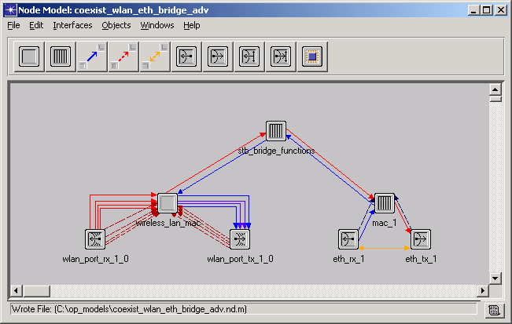
Figure 13 – WLAN Ethernet Bridge Node Model

Table 9 – WLAN Ethernet Bridge Node Process Models
Object Name | Model | Class | Description
stb_bridge_functions | bridge_dispatch_v2 | Processor | - Standard OPNET™ bridge dispatch process
wireless_lan_mac | wlan_mac | Processor | - MAC layer processing of packets according to 802.11 protocol
wlan_port_rx0 | receiver object | Radio Transceiver | - Transmits packets over radio
wlan_port_tx0 | transmitter object | Radio Transceiver | - Receives packets over radio
mac_1 | ethernet_mac_v2 | Processor | - Standard OPNET™ Ethernet MAC layer processing
eth_rx_1 | receiver object | Point-to-point Transceiver | - Receives packets
eth_tx_1 | transmitter object | Point-to-point Transceiver | - Transmits packets

Table 10 – WLAN Ethernet Bridge Node Attributes
Attribute name | Description | Type/Default
Modulation | - Name of modulation curve used by pipeline stages | list choice (CCK_11mbps)
Transmit Power (W) | - Radio transmitter power for this station in Watts | float (0.03)
Wireless LAN Parameters | - Settings of physical characteristics, data rate, etc. | compound attribute

coexist_wlan_ethernet_router_adv.nd.m

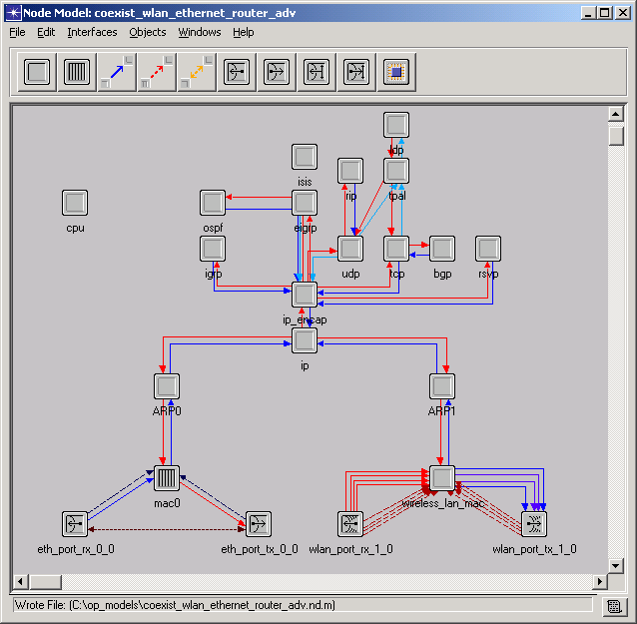
Figure 14 – WLAN Ethernet Router Node Model

Table 11 – WLAN Ethernet Router Node Process Models
Object Name | Model | Class | Description
cpu | oms_resource_manager | Processor | - Standard OPNET™ resource management process
ldp | mpls_ldp_mgr | Processor | - Standard OPNET™ LDP process
isis | isis | Processor | - Standard OPNET™ ISIS process
rip | rip_v3 | Processor | - Standard OPNET™ RIP process
tpal | tpal_v3 | Processor | - Standard OPNET™ TPAL process
ospf | ospf_v2 | Processor | - Standard OPNET™ OSPF process
igrp | igrp | Processor | - Standard OPNET™ IGRP process
eigrp | eigrp | Processor | - Standard OPNET™ EIGRP process
udp | rip_udp_v3 | Processor | - Standard OPNET™ UDP process
tcp | tcp_manager_v3 | Processor | - Standard OPNET™ TCP process
bgp | bgp | Processor | - Standard OPNET™ BGP process
rsvp | rsvp | Processor | - Standard OPNET™ RSVP process
ip_encap | ip_encap_v4 | Processor | - Standard OPNET™ IP encapsulation process
ip | ip_dispatch | Processor | - Standard OPNET™ IP process
ARP0 | ip_arp_v4 | Processor | - Standard OPNET™ ARP process
ARP1 | ip_arp_v4 | Processor | - Standard OPNET™ ARP process
mac0 | ethernet_mac_v2 | Processor | - Standard OPNET™ Ethernet MAC layer processing
eth_port_rx_0_0 | receiver object | Point-to-point Transceiver | - Receives packets
eth_port_tx_0_0 | transmitter object | Point-to-point Transceiver | - Transmits packets
wireless_lan_mac | wlan_mac | Processor | - MAC layer processing of packets according to 802.11 protocol
wlan_port_rx0 | receiver object | Radio Transceiver | - Transmits packets by radio
wlan_port_tx0 | transmitter object | Radio Transceiver | - Receives packets by radio

Table 12 – WLAN Ethernet Router Node Attributes
Attribute name | Description | Type/Default
Modulation | - Name of modulation curve used by pipeline stages | list choice (CCK_11mbps)
Transmit Power (W) | - Radio transmitter power for this station in Watts | float (0.03)
Wireless LAN Parameters | - Settings of physical characteristics, data rate, etc. | compound attribute

coexist_wlan_server_adv.nd.m

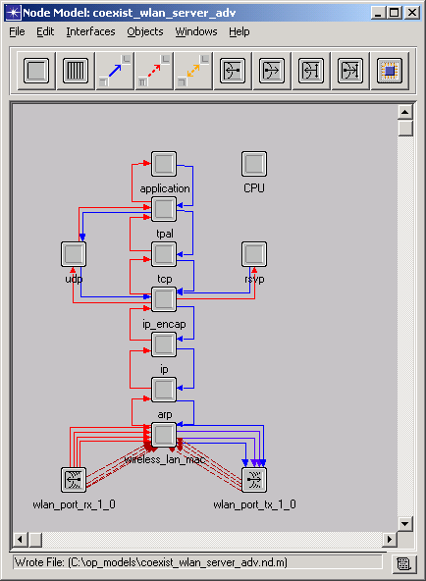
Figure 15 – WLAN Server Node Model

Table 13 – WLAN Server Node Process Models
Object Name | Model | Class | Description
CPU | server_mgr | Processor | - Standard OPNET™ server manager process
application | gna_clsvr_mgr | Processor | - Standard OPNET™ application process
tpal | tpal_v3 | Processor | - Standard OPNET™ TPAL process
udp | rip_udp_v3 | Processor | - Standard OPNET™ UDP process
rsvp | rsvp | Processor | - Standard OPNET™ RSVP process
tcp | tcp_manager_v3 | Processor | - Standard OPNET™ TCP process
ip_encap | ip_encap_v4 | Processor | - Standard OPNET™ IP encapsulation process
ip | ip_dispatch | Processor | - Standard OPNET™ IP process
arp | ip_arp_v4 | Processor | - Standard OPNET™ ARP process
wireless_lan_mac | wlan_mac | Processor | - MAC layer processing of packets according to 802.11 protocol
wlan_port_rx0 | receiver object | Radio Transceiver | - Transmits packets by radio
wlan_port_tx0 | transmitter object | Radio Transceiver | - Receives packets by radio

Table 14 – WLAN Server Node Attributes
Attribute name | Description | Type/Default
Modulation | - Name of modulation curve used by pipeline stages | list choice (CCK_11mbps)
Transmit Power (W) | - Radio transmitter power for this station in Watts | float (0.03)
Wireless LAN Parameters | - Settings of physical characteristics, data rate, etc. | compound attribute

coexist_wlan_station_adv.nd.m

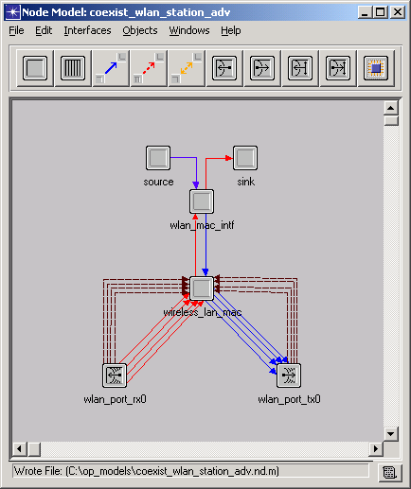
Figure 16 – WLAN Station Node Model

Table 15 – WLAN Station Node Process Models
Object Name | Model | Class | Description
source | bursty_source | Processor | - Traffic generation process
sink | sink | Processor | - Traffic collection process
wlan_mac_intf | wlan_mac_interface | Processor | - Standard OPNET™ WLAN interface process
wireless_lan_mac | wlan_mac | Processor | - MAC layer processing of packets according to 802.11 protocol
wlan_port_tx0 | transmitter object | Radio Transceiver | - Transmits packets by radio
wlan_port_rx0 | receiver object | Radio Transceiver | - Receives packets by radio

Table 16 – WLAN Station Node Attributes
Attribute name | Description | Type/Default
Modulation | - Name of modulation curve used by pipeline stages | list choice (CCK11mbps)
Transmit Power (W) | - Radio transmitter power for this station in Watts | float (0.03)
Wireless LAN Parameters | - Settings of physical characteristics, data rate, etc. | compound attribute

coexist_wlan_wkstn_adv.nd.m

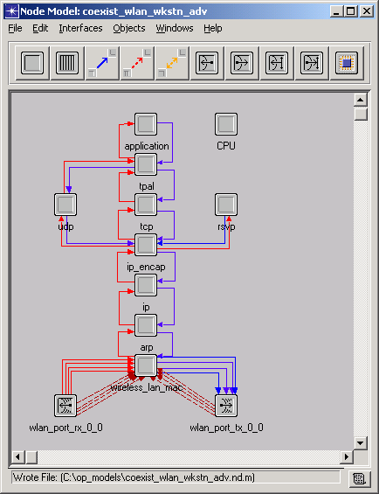
Figure 17 – WLAN Workstation Node Model

Table 17 – WLAN Workstation Node Process Models
Object Name | Model | Class | Description
CPU | server_mgr | Processor | - Standard OPNET™ server manager process
application | gna_clsvr_mgr | Processor | - Standard OPNET™ application process
tpal | tpal_v3 | Processor | - Standard OPNET™ TPAL process
udp | rip_udp_v3 | Processor | - Standard OPNET™ UDP process
rsvp | rsvp | Processor | - Standard OPNET™ RSVP process
tcp | tcp_manager_v3 | Processor | - Standard OPNET™ TCP process
ip_encap | ip_encap_v4 | Processor | - Standard OPNET™ IP encapsulation process
ip | ip_dispatch | Processor | - Standard OPNET™ IP process
arp | ip_arp_v4 | Processor | - Standard OPNET™ ARP process
wireless_lan_mac | wlan_mac | Processor | - MAC layer processing of packets according to 802.11 protocol
wlan_port_rx0 | receiver object | Radio Transceiver | - Transmits packets by radio
wlan_port_tx0 | transmitter object | Radio Transceiver | - Receives packets by radio

Table 18 – WLAN Workstation Node Attributes
Attribute name | Description | Type/Default
Modulation | - Name of modulation curve used by pipeline stages | list choice (CCK11mbps)
Transmit Power (W) | - Radio transmitter power for this station in Watts | float (0.03)
Wireless LAN Parameters | - Settings of physical characteristics, data rate, etc. | compound attribute

suitetooth_app_model.nd.m and suitetooth_profile_model.nd.m
These nodes are used by the Scenario Creation Utility to have specific default settings selected when a new scenario is created. It is not necessary that these particular application and profile nodes be used in a SuiteTooth scenario.

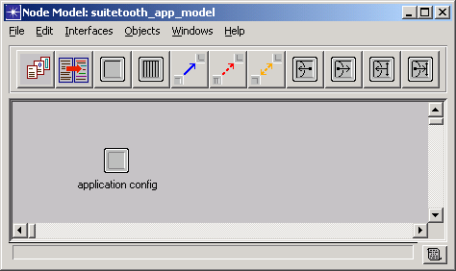

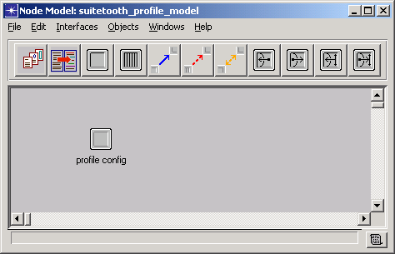
Figure 18 – SuiteTooth Configuration Node Models

Table 19 – Application and Profile Node Process Models

Object Name | Model | Class | Description
application config | application_config | Processor | - Specifies applications using available application types
profile config | profile_config | Processor | - Used to create user profiles

Table 20 – Application and Profile Node Attributes
Attributes listed for the SuiteTooth models are those that differ from the default settings of the standard application and profile configuration nodes.

Attribute name | Description | Type/Default
Application Configuration Node:  Application Definitions | - Sets list of applications available for use in profiles | list choice  (Default)
Profile Configuration Node:  Profile Configuration | - Sets list of profiles available to application processes of nodes | list choice  (Sample Profiles)

jammer.nd.m

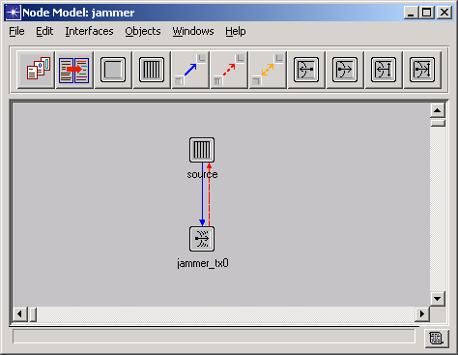
Figure 19 – Jammer Node Model

Table 21 – Jammer Node Process Models
Object Name | Model | Class | Description
source | jammer_source | Processor | - Traffic generation process
jammer_tx0 | transmitter object | Radio Transceiver | - Transmits packets by radio

Table 22 – Jammer Node Attributes
Attribute name | Description | Type/Default
Bandwidth | - Bandwidth of jamming transmissions in kHz | distribution (constant, 100000)
Interarrival Time | - Interarrival time for packet generation in seconds | distribution (exponential, 1)
Minimum Frequency | - Minimum frequency of jamming transmissions in MHz | distribution (constant, 2400)
Modulation | - Name of modulation curve to use for jamming transmissions | list choice (bpsk)
Packet Size | - Packet size in bits to be generated by this jammer | distribution (constant, 1)
Power | - Radio transmitter power for this station in Watts | distribution (exponential, 1)

Process Model Reference

bt_master.pr.m
The Bluetooth™ Master process contains the Bluetooth™ protocol logic required for a master to control a piconet. Most of the tasks performed are done via function calls. This process
- Schedules ACL and SCO transmissions to the slaves within the piconet so as not to conflict
- Creates Bluetooth™ packets for delivery on the appropriate link
- Manages all inter-piconet addressing
- Implements a polling algorithm
- Receives SDU’s from higher layers. This may be stochastically generated ACL or SCO, LMP/Control, or IP traffic.
- Controls the frequency hopping of all transceivers in the piconet as per the spec.

In addition, this process contains the necessary hooks to implement vendor specific protocol performance adaptations, such as customizing ACL packet size selection and performance driven switch between medium and high data rate ACL transmission.

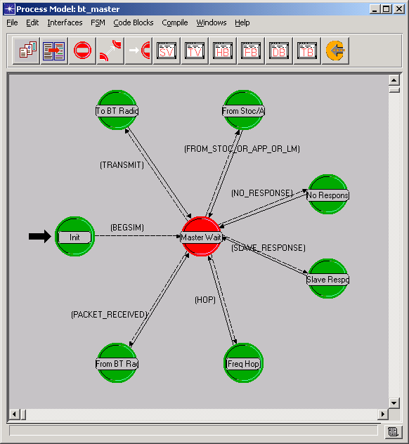
Figure 20 – Bluetooth™ Master Process Model

bt_master_arp.pr.m
The Bluetooth™ Master ARP process
- Maps IP destination address to the Bluetooth™ slave address, sets this in the ici and forwards the packet to the lower layer
- Forwards all lower layer packets received to the higher layer

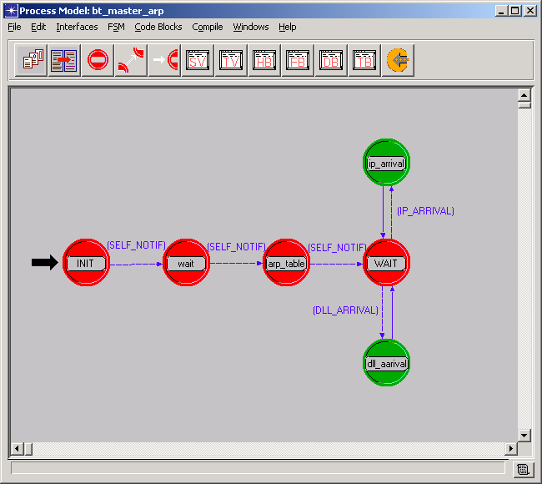
Figure 21 – Bluetooth™ Master ARP Process Model

bt_mst_lmp_src_sink.pr.m
The Bluetooth™ Master Link Manager process is primarily a placeholder for custom LMP messaging. Its current functionality is to:
- Stochastically generate packets of up to 17 bytes. Since LM payloads are always transmitted in DM1 packets, payload generation size is limited to 17 bytes.
- Receive and sink LMP payloads.
- Record statistics on received and/or sent LMP traffic.

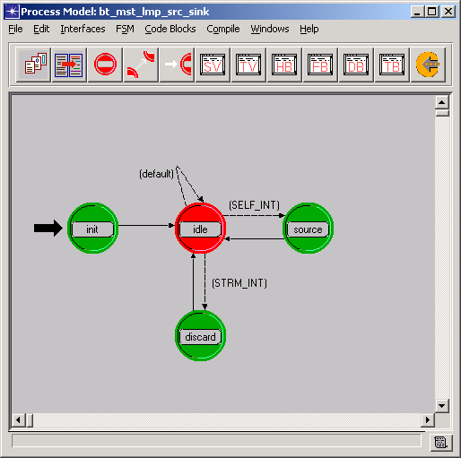
Figure 22 – Bluetooth™ Master Link Manager Protocol (LMP) Process Model

bt_mst_sto_src_sink.pr.m
The Bluetooth™ Master Stochastic Source/Sink model is responsible for generating and sinking stochastically generated ACL and SCO traffic. The advantage to using a stochastic source is faster simulation run time and tighter control over MAC loads. This process’s primary tasks are to
- Generate payloads for ACL and/or SCO traffic based on user settings: packet size, interarrival time, start time, stop time, slave destination address, and QOS (data/voice).
- Sink payloads received from slaves and record appropriate statistics.

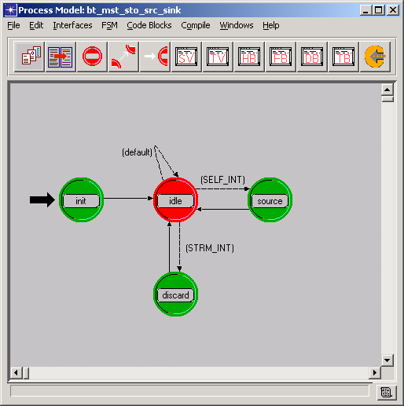
Figure 23 – Bluetooth™ Master Stochastic Source/Sink Process Model

bt_slave.pr.m
The Bluetooth™ slave process model controls the slave’s participation in its piconet. It ensures that it only transmits if in the previous slot it received a packet from its master, or in the case of a scheduled voice connection, no other slave in it’s piconet was sent a packet in the previous slot.

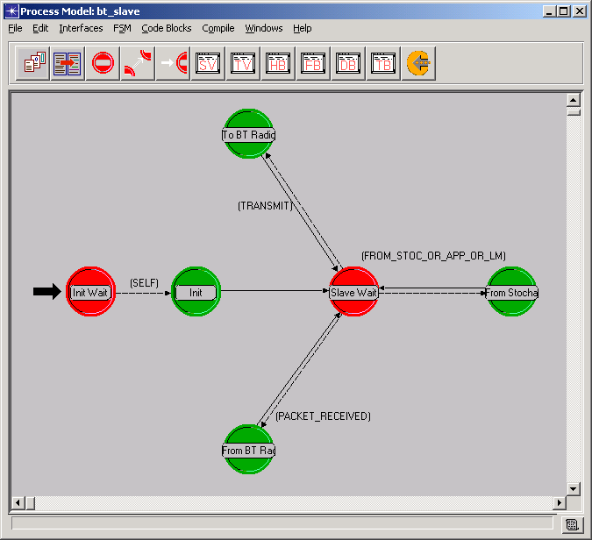
Figure 24 – Bluetooth™ Slave Process Model

bt_slave_arp.pr.m
The Bluetooth™ Slave ARP process
- Forwards all higher layer packets to the lower layer with appropriate ici and quality of service set to data
- Forwards all lower layer packets received to the higher layer

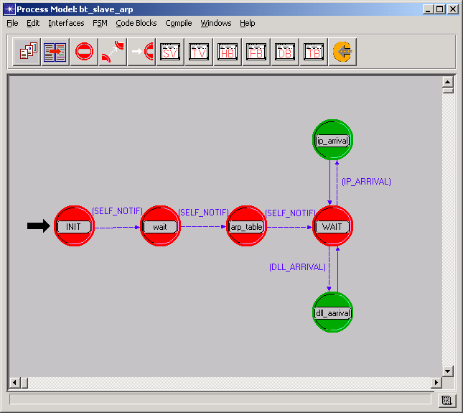
Figure 25 – Bluetooth™ Slave ARP Process Model

bt_slave_lmp_src_sink.pr.m
This process performs the same actions as the bt_mst_lmp_src_sink.pr.m, 5.3.3. It is used in conjunction with the slave process model.

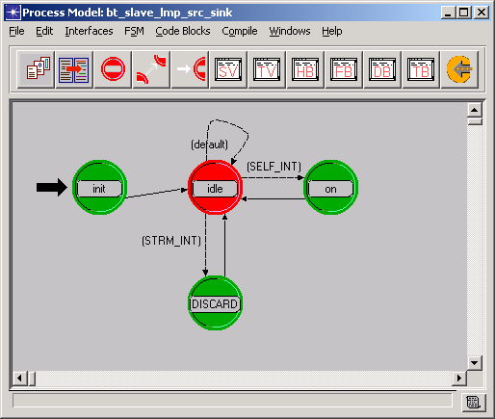
Figure 26 – Bluetooth™ Slave Link Manager Protocol (LMP) Process Model

bt_slave_sto_src_sink.pr.m
This process performs the same actions as the bt_mst_sto_src_sink.pr.m process, 5.3.4, except that it does not need a destination address since a slave can only send traffic to its master. It is used in conjunction with the slave process model.

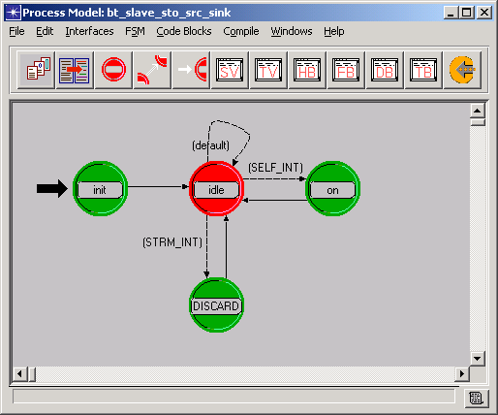
Figure 27 – Bluetooth™ Slave Stochastic Source/Sink Process Model

Bluetooth™ transmitter and receiver
The frequency and bandwidth of Bluetooth™ transmissions are controlled by the functions of the protocol. Settings of min frequency and bandwidth at the node level will not affect the actual frequency and bandwidth settings modeled in transmissions.

Table 23 – Bluetooth™ Transmitter Attributes
 | Attributes | Bluetooth™ Node Default
TX channel attributes | data rate (bps) | 1,000,000
TX channel attributes | packet formats | all formatted, unformatted
TX channel attributes | bandwidth (kHz) | 1,000
TX channel attributes | min frequency (MHz) | 2,400
TX channel attributes | spreading code | disabled
TX channel attributes | power (W) | promoted
TX pipeline stages | rxgroup | dra_rxgroup
TX pipeline stages | txdel | dra_txdel
TX pipeline stages | closure | dra_closure_all
TX pipeline stages | chanmatch | coexist_chanmatch
TX pipeline stages | tagain | dra_tagain
TX pipeline stages | propdel | dra_propdel

Table 24 – Bluetooth™ Receiver Attributes
 | Attributes | Bluetooth™ Node Default
Rx channel attributes | data rate (bps) | 1,000,000
Rx channel attributes | packet formats | all formatted, unformatted
Rx channel attributes | bandwidth (kHz) | 1,000
Rx channel attributes | min frequency (MHz) | 2,400
Rx channel attributes | spreading code | disabled
Rx channel attributes | processing gain (dB) | channel bw/dr
Rx pipeline stages | ragain | dra_ragain
Rx pipeline stages | power | coexist_bt_power
Rx pipeline stages | bkgnoise | coexist_bkgnoise
Rx pipeline stages | inoise | coexist_bt_inoise
Rx pipeline stages | snr | dra_snr
Rx pipeline stages | ber | dra_ber
Rx pipeline stages | error | coexist_bt_error
Rx pipeline stages | ecc | coexist_bt_ecc

WLAN transmitter and receiver
WLAN nodes may communicate even though data rate settings are different. This is true for standard WLAN nodes as well as SuiteTooth’s models.

Table 25 – Coexistence WLAN Transmitter Attributes
 | Attributes | Coexistence  WLAN Node Default
TX channel attributes | data rate (bps) | Four rates: 1000000, 2000000, 5500000, and 11000000
TX channel attributes | packet formats | all formatted, unformatted
TX channel attributes | bandwidth (kHz) | 22,000
TX channel attributes | min frequency (MHz) | 2,402
TX channel attributes | spreading code | disabled
TX channel attributes | power (W) | promoted
TX pipeline stages | rxgroup | coexist_wlan_rxgroup
TX pipeline stages | txdel | dra_txdel
TX pipeline stages | closure | dra_closure_all
TX pipeline stages | chanmatch | coexist_chanmatch
TX pipeline stages | tagain | dra_tagain
TX pipeline stages | propdel | wlan_propdel

Table 26 – Coexistence WLAN Receiver Attributes
 | Attributes | Coexistence  WLAN Node Default
Rx channel attributes | data rate (bps) | Four rates: 1000000, 2000000, 5500000, and 11000000
Rx channel attributes | packet formats | all formatted, unformatted
Rx channel attributes | bandwidth (kHz) | 22,000
Rx channel attributes | min frequency (MHz) | 2,402
Rx channel attributes | spreading code | disabled
Rx channel attributes | processing gain (dB) | channel bw/dr
Rx pipeline stages | ragain | dra_ragain
Rx pipeline stages | power | coexist_wlan_power
Rx pipeline stages | bkgnoise | coexist_bkgnoise
Rx pipeline stages | inoise | coexist_wlan_inoise
Rx pipeline stages | snr | dra_snr
Rx pipeline stages | ber | dra_ber
Rx pipeline stages | error | dra_error
Rx pipeline stages | ecc | wlan_ecc

jammer_source.pr.m
The jammer_source process creates and sends packets at a user specified rate on a radio channel. The user can specify how often the packets are sent and the size of the packets. The bandwidth, power and frequency is set each time a packet is transmitted based on the attributes specified by the user. If a packet is to be sent but the transmitter is busy, the packets are queued until they can be transmitted so the channel attributes can be set at that time. The default settings send packets constantly.

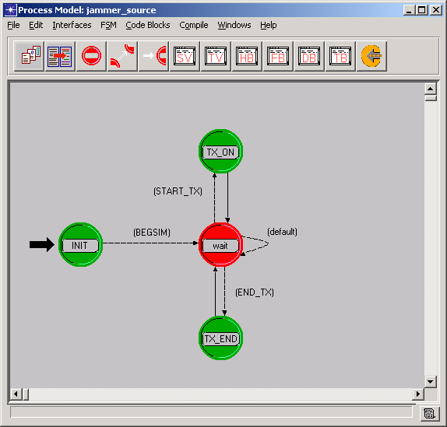
Figure 28 – Jammer Source Process Model

Packet Model Reference

Bluetooth™ Packet Types

Stochastic Application Packet Types

There are two packet formats, bt_control.pk.m and bt_source.pk.m, that don’t contain any fields. They are simply for determining packet formats in the Bluetooth™ MAC (master and slave models).

Bluetooth™ Protocol Packet Types

ACL and SCO packets (DV type excepted) are modeled as per the Bluetooth™ specification. The following tables show the packet fields modeled in the SuiteTooth packets. Fields not named in the specification may be included as zero-bit fields for simulation purposes.

Table 27 lists all the fields included in Bluetooth™ packets. Not all fields are in every packet. Table 28 matches individual fields to individual packet types.

Figures 31, 32, and 33 show packet formats for DH1, HV1, and POLL packets, respectively. The remaining packet types aren’t shown, but the differences can be determined from tables 27 and 28.

Table 27 – SuiteTooth Packet Field Data Types and Sizes
Packet Field | Data Type | Size (bits)
Access Code | integer | 72
Header | information | 54
ARQ | integer | 0
SEQN | integer | 0
AM_ADDR | integer | 0
TYPE | integer | 0
Frame Body | packet | inherited
Accept | integer | 0
Time Stamp | floating point | 0
Errors | integer | 0
Way | integer | 0
PICO_ADDR | integer | 0
L_CH | integer | 0
DM Header | integer | 16  DH1 and DM1: 8
CRC | information | 16
Last | integer | 0
FEC | HVx: information  DMx: packet | HV1: 160  HV2: 80  DMx: inherited
empty_voice_flag | integer | 0

Table 28 – Packet Fields by Packet
(default values shown where applicable)
Packet Field | DH1 | DH3 | DH5 | DM1 | DM3 | DM5 | HV1 | HV2 | HV3 | POLL | NULL
Access Code | • | • | • | • | • | • | • | • | • | • | •
Header | • | • | • | • | • | • | • | • | • | • | •
ARQ | • | • | • | • | • | • | • | • | • | • | •
SEQN | • | • | • | • | • | • | • | • | • | • | •
AM_ADDR | • | • | • | • | • | • | • | • | • | • | •
TYPE | 4 | 11 | 15 | 3 | 10 | 14 | 5 | 6 | 7 | 1 | 0
Frame Body | • | • | • | • | • | • | • | • | •
Accept | • | • | • | • | • | • | • | • | • | • | •
Time Stamp | • | • | • | • | • | • | • | • | • | • | •
Errors | • | • | • | • | • | • | • | • | • | • | •
Way | • | • | • | • | • | • | • | • | • | • | •
PICO_ADDR | • | • | • | • | • | • | • | • | • | • | •
L_CH | • | • | • | • | • | •
DM Header | • | • | • | • | • | •
CRC | • | • | • | • | • | •
Last | • | • | • | • | • | •
FEC |  |  |  | • | • | • | • | •
empty_voice_flag |  |  |  |  |  |  | • | • | •

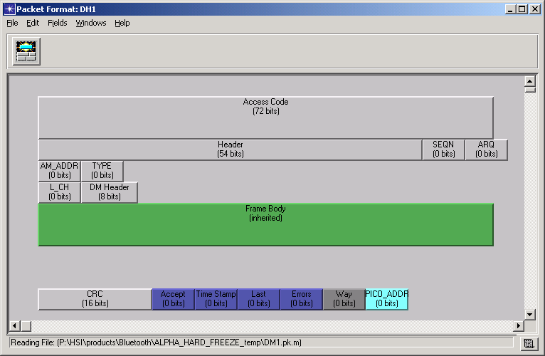
Figure 29 – DH1 Packet

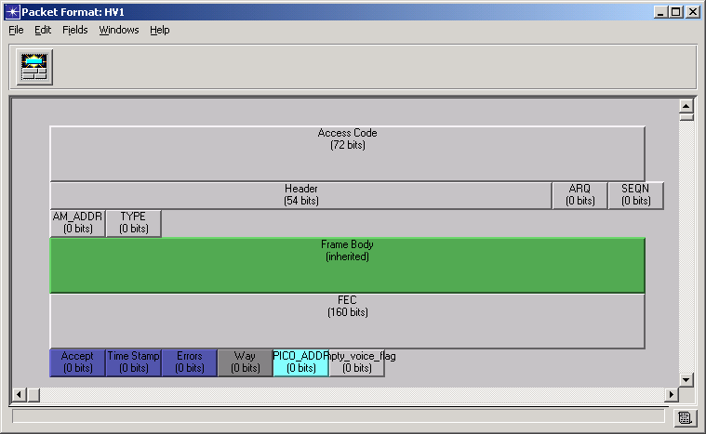
Figure 30 – HV1 Packet

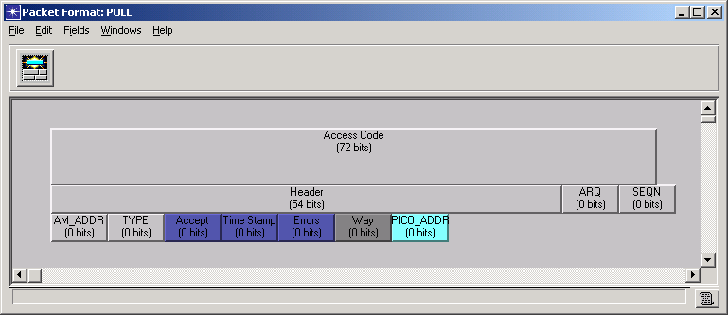
Figure 31 – POLL Packet

WLAN Packet Types

Packet formats used with the SuiteTooth coexistence WLAN models are the same as those used in the standard OPNET™ WLAN models. Details about specific packet fields may be found in OPNET™ model documentation.

wlan_mac.pk.m

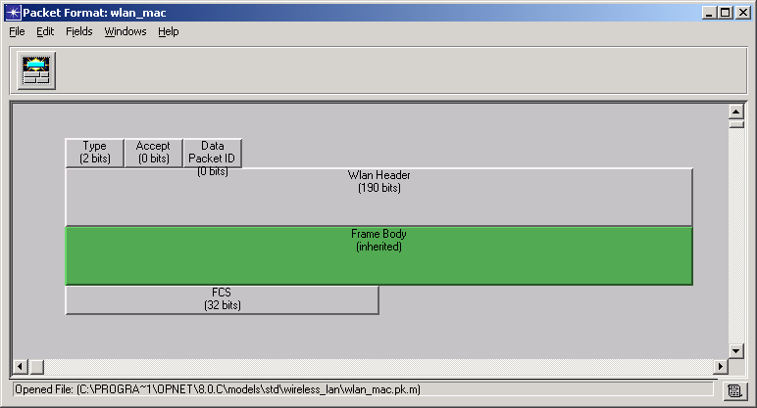
Figure 32 – wlan_mac Packet

wlan_control.pk.m

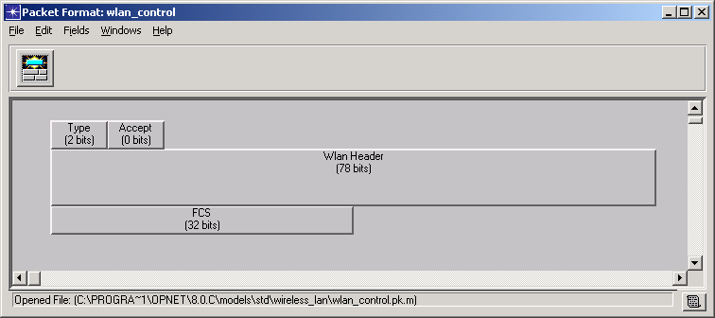
Figure 33 – wlan_control Packet

Radio Pipeline Reference

Overview
The following table is a brief summary of the transceiver pipeline design for the SuiteTooth models.

Table 29 – Bluetooth Pipeline Stages Overview
Index | Stage | Design | File Name | Notes
0 | Receiver Group | Default | dra_rxgroup | Typically includes all receivers
1 | Transmission Delay | Default | dra_txdel | Data rate / Packet size
2 | Link Closure | Default | dra_closure_all | Line of sight acceptance
3 | Channel Match | Custom | coexist_chanmatch | Classify as signal, noise, or ignore
4 | TX Antenna Gain | Default | dra_tagain | Analytical gain computation.
5 | Propagation Delay | Default | dra_propdel | Packet size / Speed of Light
6 | Rx Antenna Gain | Default | dra_ragain | Analytical gain computation.
7 | Received Power | Custom | coexist_bt_power | Indoor path loss model
8 | Background Noise | Custom | coexist_bkgnoise | Change assumptions to get realistic noise floor for each band.
9 | Interference Noise | Custom | coexist_bt_inoise | In-band non-signal packets
10 | SNR | Default | dra_snr | Signal to Noise Ratio
11 | BER | Default | dra_ber | Custom modulation curve models.
12 | Error Allocation | Custom | coexist_bt_error | Assign specific bit error locations
13 | Error Correction | Custom | coexist_bt_ecc | Account for error correcting capabilities of each band’s waveform.

Table 30 – WLAN Pipeline Stages Overview
Index | Stage | Design | File Name | Notes
0 | Receiver Group | Custom | coexist_wlan_rxgroup | Typically includes all receivers
1 | Transmission Delay | Default | dra_txdel | Data rate / Packet size
2 | Link Closure | Default | dra_closure_all | Line of sight acceptance
3 | Channel Match | Custom | coexist_chanmatch | Classify as signal, noise, or ignore
4 | TX Antenna Gain | Default | dra_tagain | Analytical gain computation.
5 | Propagation Delay | WLAN Standard | wlan_propdel | Packet size / Speed of Light
6 | Rx Antenna Gain | Default | dra_ragain | Analytical gain computation.
7 | Received Power | Custom | coexist_wlan_power | Indoor path loss model
8 | Background Noise | Custom | coexist_bkgnoise | Change assumptions to get realistic noise floor for each band.
9 | Interference Noise | Custom | coexist_wlan_inoise | In-band non-signal packets
10 | SNR | Default | dra_snr | Signal to Noise Ratio
11 | BER | Default | dra_ber | Custom modulation curve models.
12 | Error Allocation | Default | dra_error | Assign specific bit error locations
13 | Error Correction | WLAN Standard | wlan_ecc | Account for error correcting capabilities of each band’s waveform.

Receiver Group
The Receiver Group stage is a unique stage in that it is only computed once at simulation start time for each transmitter (as opposed to at each packet transmission/reception event, like other pipeline stages). It allows the transmitter to reduce the number of receiver object that may (ever) be impacted by its transmissions in a static fashion. It is used to reduce the computational complexity of the simulation in the event that it is known a priori that a specific transmitter will never impact the SNR at one or more specific receivers.

This stage may be used in the SuiteTooth models to segregate systems when it is known that those systems cannot communicate with each other or contribute to channel noise (e.g. when subnetworks are very far apart.)

Model Source | OPNET™ Standard Model
Functional Description / Scope / Fidelity | The Receiver group pipeline stage evaluates the links between radio transceivers before the packets are sent. This stage can effectively reduce the number of packets that need to be sent and significantly reduce simulation run times.
Status | Default Model. To effectively use the receiver group pipeline when nodes are moving significantly, additional code (outside this stage) would need to dynamically update the receiver group during the simulation.
Assumptions / Limitations | Standard OPNET™ documentation
Control Parameters | Standard OPNET™ documentation
Statistics | Standard OPNET™ documentation

Transmission Delay
The transmission delay stage simply computes delay associated with the serialization of the packet being transmitted. The assumption is that the receiving physical and data link layer will not be able to process incoming packets unless they are received in their entirety. If the receiving system implements any kind of “cut-through” processing (where an intermediate node begins transmission before receiving the last bit of an incoming packet), the calculation of transmission and propagation delays must be adjusted to allow reception timing that is faster than the store-and-forward method assumed by the default models.

Model Source | OPNET™ Standard Model
Functional Description / Scope / Fidelity | For all transmitted packets, the transmission delay is computed based on the channel data rate and the length of the packet, calculated using an “effective” bit rate.
Status | Default Model
Assumptions / Limitations | Bits are Data Link Frame bits (not PHY level)
Control Parameters | Length of packet (bits)  Transmitter Data Rate (bits/s)
Statistics | Transmitter Throughput (bits/s)  Channel Utilization (%)

Link Closure
The default link closure stage computes a line-of-sight ray to determine if the earth would block the transmission in question. If so, it abandons the calculation.

Model Source | OPNET™ Standard Model
Functional Description / Scope / Fidelity | For all transmitted packets, default link closure is computed based on a ray-tracing line of sight model. In the default model, if the LOS ray intersects a spherical earth model, the remainder of the pipeline is not computed.
Status | Default Model
Assumptions / Limitations | None
Control Parameters | Transmitter location  Receiver location
Statistics | None

Channel Match
The SuiteTooth channel match stage classes each packet reception in one of the following based on channel characteristics at the receiver and transmitter objects:

- Signal – all transceiver characteristics match
- Noise – not all characteristics match, but some overlap in frequency band
- Ignore – no overlap in frequency band

In addition to the default checks, the packet type and piconet address are used to classify a packet as signal or noise.

Model Source | Custom SuiteTooth Model
Functional Description / Scope / Fidelity | The default pipeline model considers a transmitter channel and a receiver channel to be compatible only if all of their common channel characteristics match. The characteristics analyzed by dra_chanmatch include frequency, bandwidth, data rate, spreading code, and modulation. The enhancements included in the coexist_chanmatch allow the packet type and piconet address to further classify a packet as either signal or noise
Status | Complete
Assumptions / Limitations | Characteristics are fixed for the length of a packet transmission (i.e. no dynamic change of frequency or any other parameter in the middle of an incoming packet).
Control Parameters | Radio channel parameters:  - frequency  - bandwidth  - data rate  - spreading code  - modulation  Packet parameters:  - packet type  - Bluetooth™ piconet address
Statistics | None

Transmitter Antenna Gain
The default antenna gain computation uses a lookup function to determine antenna gain in the direction of the receiver given the spatial orientation of the transmitting node. SuiteTooth antennas are typically omnidirectional, so this stage typically has no effect. However, if using directional antennas, a flaw in the OPNET™ paradigm restricts usable antenna patterns to those that are symmetric around one arbitrary axis.

Model Source | OPNET™ Standard Model
Functional Description / Scope / Fidelity | For all transmitted packets, the default transmitter antenna gain model, dra_tagain, computes gain based on the vector separating the transmitter and receiver and the pointing attributes of the transmitter’s associated antenna.
Status | Default Model
Assumptions / Limitations | Geometry does not change significantly during the time that it takes to transmit any single packet.
Control Parameters | Antenna pointing attributes
Statistics | None

Propagation Delay
The default propagation delay computation is simply a matter of dividing the distance between the transmitter and receiver by the speed of light.

Model Source | OPNET™ standard model
Functional Description / Scope / Fidelity | The default propagation delay model for radio links, dra_propdel, calculates delay based on the distance separating the transmitter and receiver, and the propagation velocity of radio waves.
Status | Default Model
Assumptions / Limitations | Propagation speed = c
Control Parameters | Transmitter location  Receiver location
Statistics | None

Receiver Antenna Gain
The default receiver antenna gain model is functionally identical to the transmitter antenna gain model.

Model Source | OPNET™ standard model
Functional Description / Scope / Fidelity | Receiver antenna gain is computed using the same techniques found in the transmitter antenna gain model. The implementations of these two stages differ only in that receiver-related attributes are accessed in the packet rather than transmitter-related ones.
Status | Default Model
Assumptions / Limitations | Geometry does not change significantly during the time that it takes to receive any single packet.
Control Parameters | Antenna pointing attributes
Statistics | None

Received Power
SuiteTooth received power is computed based on the selected simulation attribute “path loss model”. The choices are free space, indoor path loss (r^3.3 for r>8), or a custom path loss model created by the user. The computation accounts for transmitted power and antenna gain at both the transmitter and receiver. This stage computes received power levels in the receiver bandwidth for both signal packets and noise packets.

Model Source | Custom SuiteTooth Model
Functional Description / Scope / Fidelity | The result of the Received Power Model invocation for each packet is a single double precision floating point value, which represents the received power level for the packet. For all arriving packets, whether valid or invalid, the average power level of the received signal is computed. This takes into account the initial transmitted power, the path loss, and receiver and transmitter antenna gains.
Status | Complete
Assumptions / Limitations | This stage locks to first good packet, not necessarily the packet with the strongest signal. Partial frequency overlaps for the relatively narrow Bluetooth™ packets are considered to have complete frequency overlap.
Control Parameters | Transmitted Power  Tx Antenna Gain  Rx Antenna Gain  Path Loss Model
Statistics | Received Power (W)

Background Noise
The background noise computation attempts to determine a noise floor for the transmission band on which a good signal is received. It is a function of the Noise Figure of the receiver as well as a number of symbolic constants that account for ambient conditions. This stage is modified in SuiteTooth because the default OPNET™ stage’s ambient noise constant is too optimistic for most applications (about 79 dB for Bluetooth™).

Model Source | Custom SuiteTooth Model
Functional Description / Scope / Fidelity | The SuiteTooth procedure provided for the background noise model is coexist_bkgnoise, which is a simple model accounting for a constant ambient noise level, a constant source of background noise, and a constant thermal noise at the receiver.
Status | Complete
Assumptions / Limitations | All in-band noise is Gaussian white noise.
Control Parameters | Ambient noise symbolic constants  Background noise symbolic constants  Thermal noise symbolic constants  Receiver Noise Figure
Statistics | None

Interference Noise
The dynamic interference computation sums the effect of in-band, explicitly modeled interfering signals. Each period where the noise sum is constant is referred to as a “segment” and is assessed an interference noise value (in Watts).

Model Source | Custom SuiteTooth Model
Functional Description / Scope / Fidelity | The SuiteTooth Interference Noise Models, called coexist_bt_inoise and coexist_wlan_inoise, check for packet overlap (collisions), determine if the packets are interference packets or valid packets, and retrieve the received power levels of both packets. Computations of noise contribution are only necessary for affected valid packets, since invalid packets are not considered for reception, and their signal quality need not be determined. For packets that are valid, noise contributions from other packets are based on the interfering packets’ power level. Jammer nodes provide in-band power that contributes to the noise level.
Status | Complete
Assumptions / Limitations | All in-band noise is Gaussian white noise.
Control Parameters | Received Power on noise packets.
Statistics | None

Signal to Noise Ratio (SNR)
SNR is computed by dividing the good signal power received over any segment of an incoming packet by the sum of interference noise and background noise over the same period.

Model Source | OPNET™ standard model
Functional Description / Scope / Fidelity | The SNR computed in this stage is the ratio of the average power of the information signal to the accumulated average power of all background and interference noise sources.
Status | Default Model
Assumptions / Limitations | None
Control Parameters | Incoming packet received power.  Incoming interference packet received power, by segment.  In-band background noise.
Statistics | SNR (dB)

Bit Error Rate (BER)
BER is calculated in the default stage by a table lookup. The OPNET™ table is referred to as a “modulation function” or “modulation curve” and relates the expected, effective, Layer 2 BER to the received packet SNR. The SuiteTooth model uses the default code for this stage, but relies on customized modulation curves for each radio mode.

Customized modulation curves may be created with the Modulation Curve Creation Utility, described in section 4.2.

Model Source | OPNET™ standard model
Functional Description / Scope / Fidelity | The default model for the BER pipeline stage is called dra_ber. This model evaluates BER based on the previously computed average power SNR and accounts for processing gain at the receiver. The bit error rate is derived from the effective SNR based on a modulation function assigned to the receiver. This function, which associates a unique BER with each value of effective SNR, may be specified in the Modulation Curve Editor or via the External Model Access package.
Status | Default Model. A custom modulation curve has been developed for each waveform for use with this pipeline stage.
Assumptions / Limitations | Modulation function curve exists.
Control Parameters | Incoming packet SNR, by segment.
Statistics | Assessed BER on incoming packet.

Error Allocation
The SuiteTooth error allocation stage uses the number of bits in the incoming (Layer 2) frame and the assessed BER to feed a Monde Carlo analysis of how many bit errors has actually occurred in each particular incoming packet. The bit error locations are then specifically assigned so that the proper effect of Forward Error Correction (FEC) can be included in the Error Correction stage.

Model Source | Custom SuiteTooth Model
Functional Description / Scope / Fidelity | The task of the error allocation model is to translate the given bit error rate into an actual set of bit errors for each valid packet which is received. Because bit error rate varies with SNR, the error allocation model is called to operate on packet segments defined as portions of the packet where SNR remains constant. Thus, the error allocation model may be called several times to operate on the same packet as it traverses different phases of SNR.
Status | Complete
Assumptions / Limitations | Computes most efficiently when number of bit errors (i.e. bit error permutations over number of bits in the incoming frame) is small. For WLAN packets and any Bluetooth™ DH packets (without FEC) assessed, error location assignments cease after the first payload bit error is encountered (the packet is known to be bad).
Control Parameters | Incoming packet assessed BER, by segment.
Statistics | Number of bit errors per packet.

Error Correction
The SuiteTooth error correction stage has been extended to include FEC concepts.

Model Source | Custom SuiteTooth Model
Functional Description / Scope / Fidelity | The error correction pipeline stage, coexist_ecc, determines whether a packet can be accepted by the receiver based on the application of two criteria. The first test has to do with packets that may not have been transmitted in full due to a decision at the source to abort the transmission. Truncated packets, or runts as they are sometimes called, are filtered out as unacceptable. The second test compares the specific bit error locations with the properties of the FEC to determine if those errors can be corrected and the packet accepted as valid.
Status | Complete
Assumptions / Limitations | None
Control Parameters | Type of FEC
Statistics | None

Statistics Reference
The following table defines the local and global output statistics that are computed by the SuiteTooth models. Standard radio transmitter and receiver statistics have been promoted to the node level for easier selection, along with some standard application level statistics. The standard OPNET™ processes used in the SuiteTooth nodes also collect numerous statistics for their respective applications and protocols.

Object | Local Statistics | Global Statistics
Bluetooth™ Master  MAC Layer  (baseband) | ACL Packets Received: Records receipt of Data or Control packets from radio at the MAC level (use ‘count’ to view results)  ACL Packets Sent: Records sending of Data or Control packets to radio at the MAC level (use ‘count’ to view results)  Control Packets Received: Number of Control packets received from radio at the MAC level  Control Packets Sent: Number of Control packets sent to radio at the MAC level  Control Packets from Slave[# slaves]: Number of Control packets received from each slave of this piconet  Control Packets to Slave[# slaves]: Number of Control packets sent to each slave of this piconet  Dropped SCO Packets: SCO packets not sent due to preemption by Control packets or retransmissions  FEC Throughput (bits/sec): Number of bits received per second allocated to FEC  Hop Value: Pseudo-random number representing the frequency channel hopped onto  MAC SDU Delay: Time from packet arrival at sending MAC to time of final reassembly at receiving MAC  Null Packets Received: Records receipt of NULL packets from radio at the MAC level (use ‘count’ to view results)  Null Packets Sent: Records sending of NULL packets to radio at the MAC level (use ‘count’ to view results)  Packet Loss: Records packets received at MAC but not accepted due to errors. This will catch all packets lost due to errors because the pipeline passes all packets to the MAC.  Packets received (pkt): Records receipt of packets (any type) from radio at the MAC level (use ‘count’ to view results)  Packets sent (pkt): Records sending of packets (any type) to radio at the MAC level (use ‘count’ to view results)  Poll packets sent: Records sending of POLL packets to radio at the MAC level (use ‘count’ to view results)  Residual SCO Payload Errors: Number of bit errors remaining in payload of accepted SCO packet after error correction  Retransmissions: Retransmission of packets unacknowledged at MAC level  SCO Packets Received: Number of SCO packets received from radio at the MAC level  SCO Packets Sent: Number of SCO packets sent to radio at the MAC level  Skipped Transmissions: Packets not sent due to slot availability (attempt to send 3 slot packet when only 1 slot is available)  Throughput (bits/sec): Number of error-free bits per second received as payload (voice may show decreased throughput due to residual errors) | Aggregate Bluetooth™ Tput: Total payload throughput of all Bluetooth™ nodes in the scenario  BT Clock Offset: Piconet timing offset, a number between 0 and .00125 (one per piconet)  BT FEC Throughput (bits/sec)[# piconets]: Number of bits received per second allocated to FEC, by all nodes in piconet  BT Overhead (bits/sec)[# piconets]: Number of bits received per second that is not payload or FEC (headers, preamble, etc.), by all nodes in piconet  BT Throughput (bits/sec)[# piconets]: Number of bits received per second as error-free payload, by all nodes in piconet  Bluetooth™ Packet Loss Rate: Rate of packet loss as indicated by total packets accepted/total packets received at MAC (This statistic is not instantaneous so is most useful in scenarios absent of mobile nodes)  Master Control Packets Received: Total Number of Control packets received from radio at the MAC level by all master nodes  Master Control Packets Sent: Total number of Control packets sent to radio at the MAC level by all master nodes
Bluetooth™ Slave  MAC Layer  (baseband) | ACL Packets Received: Records receipt of Data or Control packets from radio at the MAC level (use ‘count’ to view results)  ACL Packets Sent: Records sending of Data or Control packets to radio at the MAC level (use ‘count’ to view results)  Control Packets Received: Number of Control packets received from radio at the MAC level  Control Packets Sent: Number of Control packets sent to radio at the MAC level  Dropped SCO Packets: SCO packets not sent due to preemption by Control packets or retransmissions  FEC Throughput (bits/sec): Number of bits received per second allocated to FEC  Hop Value: Pseudo-random number representing the frequency channel hopped onto  MAC SDU Delay: Time from packet arrival at sending MAC to time of final reassembly at receiving MAC  Null Packets Received: Records receipt of NULL packets from radio at the MAC level (use ‘count’ to view results)  Null Packets Sent: Records sending of NULL packets to radio at the MAC level (use ‘count’ to view results)  Packet Loss: Records packets received at MAC but not accepted due to errors (use ‘count’ to view results)  Packets received (pkt): Records receipt of packets (any type) from radio at the MAC level (use ‘count’ to view results)  Packets sent (pkt): Records sending of packets (any type) to radio at the MAC level (use ‘count’ to view results)  Poll packets received: Number of POLL packets received from radio at the MAC level  Residual SCO Payload Errors: Number of bit errors remaining in payload of accepted SCO packet after error correction  Retransmissions: Retransmission of packets unacknowledged at MAC level  SCO Packets Received: Number of SCO packets received from radio at the MAC level  SCO Packets Sent: Number of SCO packets sent to radio at the MAC level  Throughput (bits/sec): Number of error-free bits per second received as payload (voice may show decreased throughput due to residual errors) | Slave Throughput (bits/sec): Error-free bits received per second at the MAC level for all slaves in a piconet
Master & Slave Stochastic  Source/Sink | Data End-to-End Delay (seconds): Time from creation at source application layer to destruction at destination application layer – for data packets only  Data Traffic Received (bits/sec): Number of bits received per second from data packets reaching the application layer  Data Traffic Received (packets): Number of data packets received at application layer  Data Traffic Sent (bits/sec): Number of bits sent per second in data packets leaving the application layer  Data Traffic Sent (packets): Number of data packets sent from the application layer  End-to-End Delay (seconds): Time from creation at source application layer to destruction at destination application layer – data and voice packets  Packet Generation Status: Indicates that a packet is being generated at the time the statistic is written  Traffic Received (bits): Number of bits received from data and voice packets reaching the application layer  Traffic Received (bits/sec): Number of bits received per second from data and voice packets reaching the application layer  Traffic Received (packets): Number of data and voice packets received at application layer  Traffic Received (packets/sec): Number of data and voice packets received per second at application layer  Traffic Sent (bits): Number of bits sent in data and voice packets leaving the application layer  Traffic Sent (bits/sec): Number of bits sent per second in data and voice packets leaving the application layer  Traffic Sent (packets): Number of data and voice packets sent from the application layer  Traffic Sent (packets/sec): Number of data and voice packets sent per second from the application layer  Voice End-to-End Delay (seconds): Time from creation at source application layer to destruction at destination application layer – for voice packets only  Voice Traffic Received (bits/sec): Number of bits received per second from voice packets reaching the application layer  Voice Traffic Received (packets): Number of voice packets received at application layer  Voice Traffic Sent (bits/sec): Number of bits sent per second in voice packets leaving the application layer  Voice Traffic Sent (packets): Number of voice packets sent from the application layer | End-to-End Delay (seconds): Time from creation at source application layer to destruction at destination application layer – all packet types  Traffic Received (bits): Number of bits received from packets reaching the application layer  Traffic Received (bits/sec): Number of bits received per second from packets reaching the application layer  Traffic Received (packets): Number of packets received at application layer  Traffic Received (packets/sec): Number of packets received per second at application layer  Traffic Sent (bits): Number of bits sent in packets leaving the application layer  Traffic Sent (bits/sec): Number of bits sent per second in packets leaving the application layer  Traffic Sent (packets): Number of packets sent from the application layer  Traffic Sent (packets/sec): Number of packets per second sent from the application layer
Master & Slave  Control  Source/Sink | End-to-End Delay (seconds): Time from creation at source application layer to destruction at destination application layer – control packets  Packet Generation Status: Indicates that a packet is being generated at the time the statistic is written  Traffic Received (bits): Number of bits received from control packets reaching the application layer  Traffic Received (bits/sec): Number of bits received per second from control packets reaching the application layer  Traffic Received (packets): Number of control packets received at application layer  Traffic Received (packets/sec): Number of control packets received per second at application layer  Traffic Sent (bits): Number of bits sent in control packets leaving the application layer  Traffic Sent (bits/sec): Number of bits sent per second in control packets leaving the application layer  Traffic Sent (packets): Number of control packets sent from the application layer  Traffic Sent (packets/sec): Number of control packets sent per second from the application layer | End-to-End Delay (seconds): Time from creation at source application layer to destruction at destination application layer  Traffic Received (bits): Number of bits received from packets reaching the application layer  Traffic Received (bits/sec): Number of bits received per second from packets reaching the application layer  Traffic Received (packets): Number of packets received at application layer  Traffic Received (packets/sec): Number of packets received per second at application layer  Traffic Sent (bits): Number of bits sent in packets leaving the application layer  Traffic Sent (bits/sec): Number of bits sent per second in packets leaving the application layer  Traffic Sent (packets): Number of packets sent from the application layer  Traffic Sent (packets/sec): Number of packets per second sent from the application layer
Master Stochastic  Source/Sink | Traffic by Slave (packets) [#slaves]: Number of data or voice packets sent from the application layer to each slave
Master Control  Source/Sink | Traffic by Slave (packets) [#slaves]: Number of control packets sent from the application layer to each slave
WLAN  (Coexistence models) | All coexistence WLAN models collect the standard OPNET™ wireless LAN statistics.

Appendix A – Bluetooth™ Protocol Features

The following table summarizes the Bluetooth™ Protocol Requirements List component implementation status with references to the appropriate section of the Bluetooth™ protocol standards document. The letter s in the status column indicates that the requirement is supported.
Table 31 – Bluetooth™ Protocol Requirements List
Part | Reference | Title | Status | Comments
A |  | Radio Specifications
 | 2 | Frequency bands and channel arrangement | s | only the 79 hop model is supported
 | none | Indoor path loss model | s | Simulation attribute. Free space also supported.
 | none | error allocation | s | FEC set in the MAC, errors allocated in the pipeline.
 | none | error correction (FEC) | s | custom pipeline stage
B |  | Baseband
 | 2 | Physical Channel
 | 2.2 | timeslots | s
 | 3 | Physical Links
 | 3.2 | SCO links | s | Supports only one SCO link per slave/master pair. Up to 3 SCO connections per piconet (HV3 packets, no FEC).
 | 3.3 | ACL links | s
 | 4 | Packets
 | 4.2 | Access Code | s
 | 4.2.2 | preamble | s
 | 4.2.3 | sync word | s
 | 4.2.4 | trailer | s
 | 4.3 | Packet Header | s
 | 4.3.1 | am_addr | s
 | 4.3.2 | type | s
 | 4.3.3 | flow | n
 | 4.3.4
 | 4.4 | packet types
 | 4.4.1 | common | s | Supported types: NULL, POLL, DM1 Not supported: ID, FHS
 | 4.4.2 | SCO packets | s | Supported types: HV1, HV2, HV3 Not supported: DV
 | 4.4.3 | ACL packets | s | Supported types: DM1, DH1, DM3, DH3, DM5, DH5 Not supported: AUX1
 | 5 | error correction | s | in pipeline
 | 5.1 | FEC | s | Implemented in pipeline
 | 5.3 | ARQ | s
 | 5.4 | error checking | s | bit error allocation in pipeline
 | 6 | logical channels | s | control + data
 | 6.1 | LC - link control | s
 | 6.2 | LM - link manager | s | possible future development for link control data; currently modeled as stochastic source/sink.
 | 6.3 | UA/UI Channel (asynchronous/isochronous) | s | fragmentation functionality occurs via the OPNET™ SAR KP's
 | 6.4 | US (user synchronous) | s
 | 7 | data whitening | n
 | 8 | Transmit/Receive routines
 | 8.1 | TX routine
 | 8.1.1 | ACL | s
 | 8.1.2 | SCO | s
 | 8.1.3 | mixed data/voice | n
 | 8.2 | RX | s
 | 8.3 | Flow Control | n
 | 9 | Transmit/Receive timing
 | 9.1 | master/slave timing synch | s | all nodes in OPNET™ use the same clock
 | 9.2 | connection state | s | active only
 | 9.3 | return from hold mode | n
 | 9.4 | park and sniff modes wake-up | n
 | 9.5 | page state | n
 | 9.6 | FHS packet | n
 | 9.7 | Multi-slave operation | s
 | 10 | channel control |  | By logical channel
 | 10.5 | standby state | n
 | 10.6 | access procedures (pages) | n
 | 10.7 | inquiry procedures | n
 | 10.8 | connection state
 | 10.8.1 | active mode | s
 | 10.8.2 | sniff mode | n
 | 10.8.3 | hold mode | n
 | 10.8.4 | park mode | n
 | 10.8.5 | polling schemes | s
 | 10.8.6 | slot reservation scheme | s | user defined function or hardwire to #slots
 | 10.8.7 | Broadcast scheme | n
 | 10.9 | scatternet | n
 | 10.9.2 | inter-piconet communications | n
 | 10.9.3 | master-slave switch | n
 | 10.1 | power management | n
 | 11 | hop selection | s | adopted from NIST OPNET™ contributed models
 | 12 | BT audio | n
 | 13 | BT addressing | s | AM_ADDR only; piconets identified by integer id
 | 14 | BT security | n
C |  | Link Manager Protocol |  | Separate process; acts as source and sink of control info only.
 | 3.8 | slot offset info | n
 | 3.12 | switch of master-slave role | n
 | 3.15 | hold mode | n
 | 3.16 | sniff mode | n
 | 3.17 | park mode | n
 | 3.18 | power control
 | 3.19 | channel quality driven switch between DM and DH | n | straightforward implementation hooks are in place (bt_master.pr.m)
 | 3.20 | QOS | n
 | 3.21 | SCO links | n
 | 3.21.1 | master initiates | n
 | 3.21.2 | slave initiates | n
 | 3.21.3 | master requests change of SCO parameters | n
 | 3.21.4 | slave requests change of SCO parameters | n
 | 3.21.5 | remove an SCO link | n
 | 3.22 | control of multi-slot packets | n
 | 3.23 | paging scheme | n
D |  | L2CAP
 | 2.3 | operation between layers | s | bt_master_arp.pr.m and bt_slave_arp.pr.m provide the interface between Bluetooth™ nodes and a full TCP/IP stack.
 | 2.4 | segmentation and reassembly | s | Performed by OPNET™ SAR buffers in the MAC models.

Appendix B – Included Files

Table 32 – List of Files in the SuiteTooth_models Directory
Filename | Description
ber.txt | input file for modulation curve creation utility
ber_calc_log.em.c | source code for modulation curve utility
ber_calc_log.i0.em.x | executable for modulation curve utility
Bluehoc.md.m | modulation curve that provides a conversion from signal-to-noise ratio (SNR) to bit error rate (BER)
bluetooth_mac_ind.ic.m | ici format model
bt_master.pr.m | Bluetooth™ master MAC OPNET™ process model
bt_master_arp.pr.m | Bluetooth™ master ARP model
bt_master_nd.nd.m | Bluetooth™ master node model
bt_mst_lmp_src_sink.pr.m | Bluetooth™ master control source/sink process model
bt_mst_sto_src_sink.pr.m | Bluetooth™ master stochastic source/sink process model
bt_slave.pr.m | Bluetooth™ slave MAC OPNET™ process model
bt_slave_arp.pr.m | Bluetooth™ slave ARP model
bt_slave_lmp_src_sink.pr.m | Bluetooth™ slave control source/sink process model
bt_slave_nd.nd.m | Bluetooth™ slave node model
bt_slave_sto_src_sink.pr.m | Bluetooth™ slave stochastic source/sink process model
bt_source.pk.m | packet format model
CCK_11mbps.md.m | modulation curve that provides a conversion from signal-to-noise ratio (SNR) to bit error rate (BER)
coexist_bkgnoise.ps.c | coexistence radio pipeline
coexist_bt_ecc.ps.c | coexistence radio pipeline
coexist_bt_error.ps.c | coexistence radio pipeline
coexist_bt_inoise.ps.c | coexistence radio pipeline
coexist_bt_power.ps.c | coexistence radio pipeline
coexist_chanmatch.ps.c | coexistence radio pipeline
Coexist_Pipeline.h | header file
coexist_wlan_inoise.ps.c | coexistence radio pipeline
coexist_power.ps.c | coexistence radio pipeline
coexist_wlan_eth_bridge_adv.nd.m | coexistence WLAN node model
coexist_wlan_ethernet_router_adv.nd.m | coexistence WLAN node model
coexist_wlan_inoise.ps.c | coexistence radio pipeline
coexist_wlan_power.ps.c | coexistence radio pipeline
coexist_wlan_rxgroup.ps.c | coexistence radio pipeline
coexist_wlan_server_adv.nd.m | coexistence WLAN node model
coexist_wlan_station_adv.nd.m | coexistence WLAN node model
coexist_wlan_wkstn_adv.nd.m | coexistence WLAN node model
count.fl.x | filter
count.pd.m
DH1.pk.m | packet format model
DH3.pk.m | packet format model
DH5.pk.m | packet format model
DM1.pk.m | packet format model
DM3.pk.m | packet format model
DM5.pk.m | packet format model
fast_server.nd.m | server node model
Format_Information.csv | packet format information file
HV1.pk.m | packet format model
HV2.pk.m | packet format model
HV3.pk.m | packet format model
jammer.nd.m | jammer node model
jammer_source.pr.m | jammer process model
NIST_TCP_IP.pd.m | PDF file
NIST_TCP_IP.pd.s | PDF file
NULL.pk.m | packet format model
POLL.pk.m | packet format model
suitetooth_app_model.nd.m | application configuration node
suitetooth_profile_model.nd.m | profile configuration node
W_to_DBm.fl.m | filter model
W_to_DBm.fl.x | filter

Table 33 – List of files in the SuiteTooth_ets Directory
File name | Description | Type
modeler.ets | Top level ETS file. Defines the standard OPNET™ interface. This version has the SuiteTooth Scenario Creation Utility additions. | ETS
std_network_suitetooth_network_operations.ets | ETS additions to the OPNET™ network interface. Enables the Scenario Creation Utility buttons and menu options. | ETS
suitetooth_event_handler.so | Supplement to the standard OPNET™ event handler. Enables activation of the Scenario Creation Utility interface and handles user interaction. | Shared object
SuiteTooth_project_exec.ets | ETS definitions of the Scenario Creation Utility interface. Defines Scenario Creation Utility window and related controls. | ETS
SuiteToothnet.em.c | EMA application code | source code
suitetoothnet.i0.em.x | EMA executable. Responsible for accepting input from the Scenario Creation Utility interface and creating a new network model. | EMA Executable
SuiteToothnet.nt.m | Network model | Model

Appendix C – REFERENCES

OPNET™ Modeler Documentation
Bluetooth™ Standards document

